
MSME TECHNOLOGY CENTRE –VISAKHAPATNAM
(A Govt. of India Society, Ministry of MSME) Govt. of India; Mint. of MSME
AP MSME DC –ESDP Under RAMP
Entrepreneurship cum Skill Development Program
Engineering Domain: Computer Science Engineering (CSE)
Topic: Data Analytics & ML
Batch ID: ESDP-NTR-00006 & ESDP-NTR-00006
Resource Person: Madala Jyothi Sri
Module 1 : Introduction to Data Analytics & Python Setup
Topics: Overview of Data Analytics, Importance for Entrepreneurs, Understanding Data-Driven Decisions, Installing Anaconda & Jupyter Notebook, Introduction to Python Environment and Syntax, Writing Basic Python Programs.

Notes:
1. Overview of Data Analytics
Data Analytics is the process of collecting, cleaning, analyzing, and interpreting data to uncover meaningful insights that support decision-making. It involves techniques such as descriptive statistics, data visualization, pattern finding, prediction, and performance tracking. Tools like Python, SQL, Excel, and visualization platforms (Power BI, Tableau) help analysts convert raw data into actionable insights.
Tools Used in Data Analytics
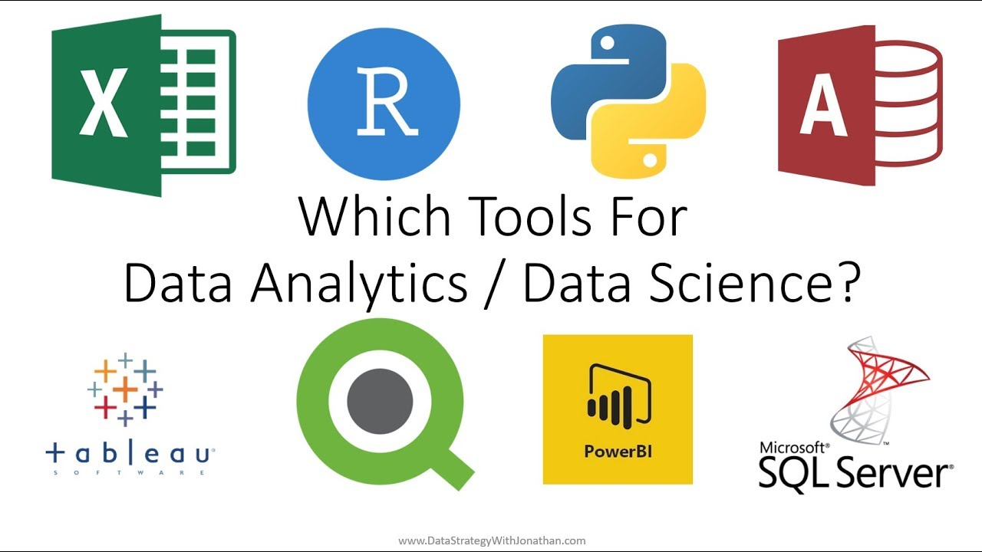

1. Excel
- Used for basic data cleaning, charts, pivot tables, and simple analysis.

2. SQL
- Used to query, filter, join, and manage data stored in databases.

3. Python
- Popular for data cleaning, visualization, and machine learning (Pandas, NumPy, Matplotlib).

4. R Programming
- Used for statistical analysis and research-oriented analytics.

5. Power BI
- Interactive dashboards, business reports, DAX functions, and data modeling.

6. Tableau
- Advanced data visual storytelling, dashboards, and analytics.

7. Google Analytics
- Used for website performance, user behavior, and marketing analytics.

8. Apache Hadoop / Spark
- Used for Big Data processing and real-time analytics.
Types of Data
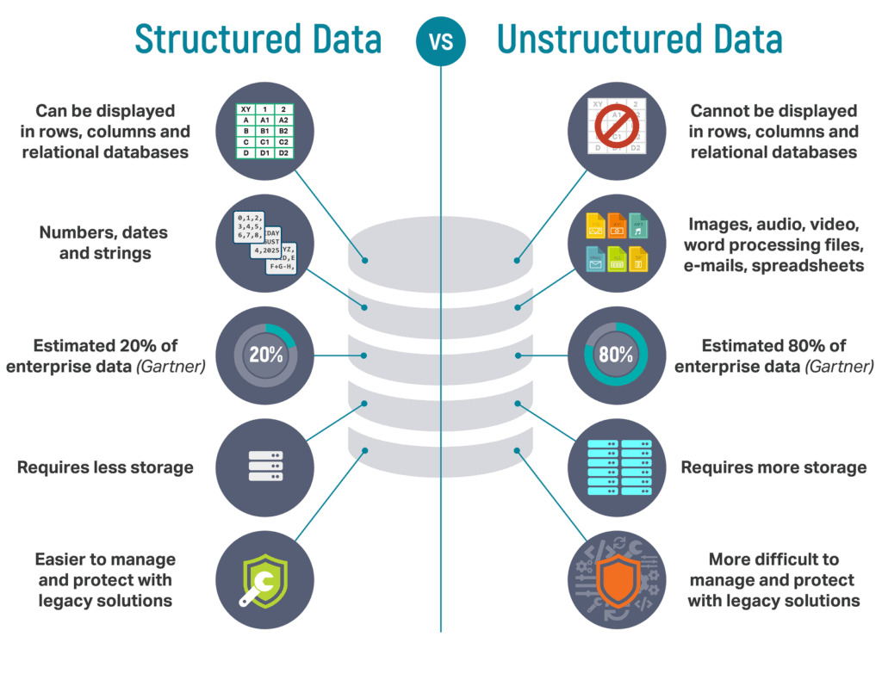
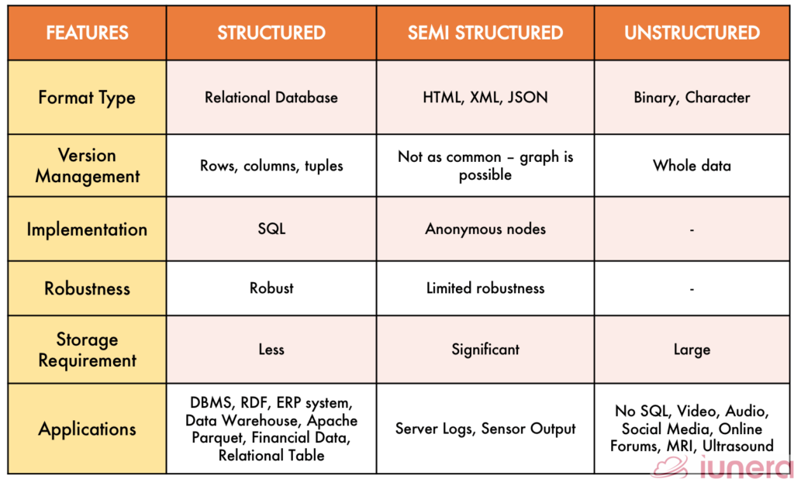

1. Structured Data
- Data arranged in rows and columns.
- Easy to store in databases (SQL).
- Examples: Excel sheets, bank records, employee data.

2. Unstructured Data
- No fixed format or structure.
- Difficult to store and analyze.
- Examples: Images, videos, audio, social media posts.

3. Semi-Structured Data
- Not fully structured but has tags or markers.
- Examples: JSON files, XML files, emails.

4. Quantitative Data
- Numerical data used to measure quantities.
- Example: salary, age, profit, marks.

5. Qualitative Data
- Descriptive, non-numerical data.
- Example: feedback, reviews, opinions, color names.
Types of Data Analytics
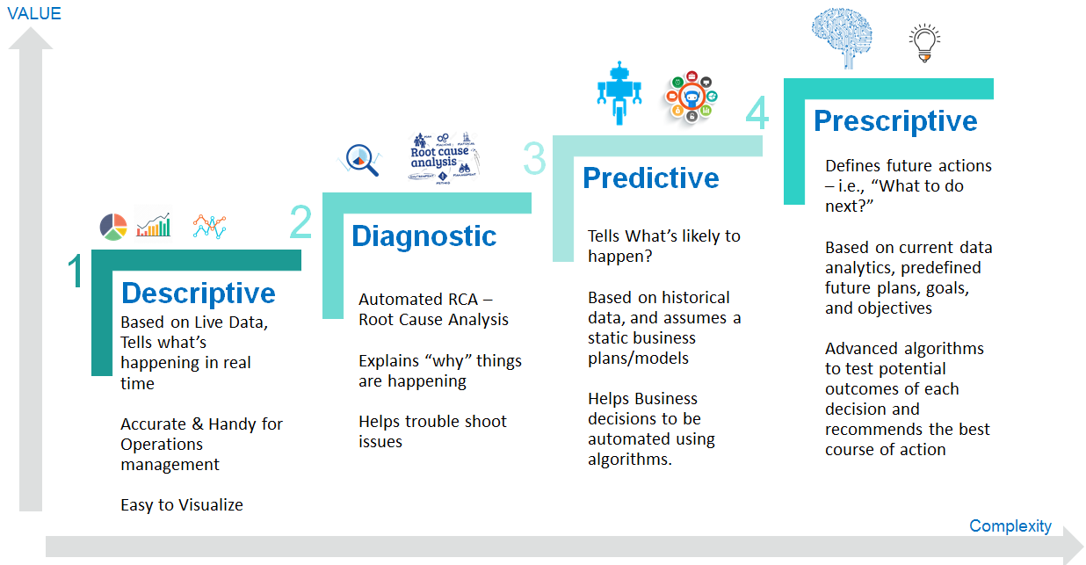
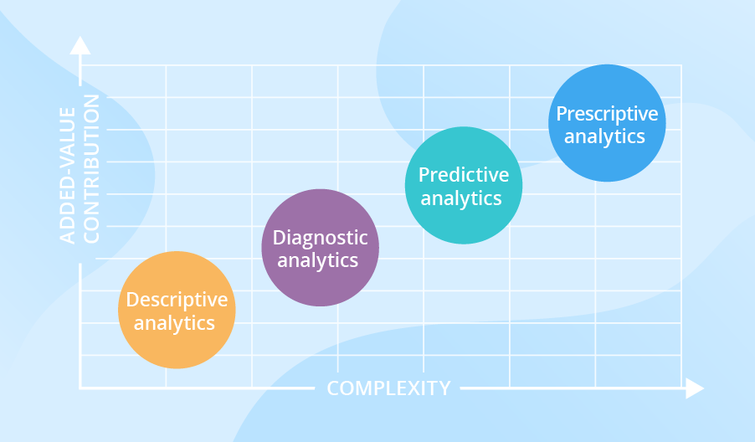

1. Descriptive Analytics – “What Happened?”
- Summarizes past data.
- Example: Sales report, attendance report, profit summary.

2. Diagnostic Analytics – “Why Did It Happen?”
- Identifies reasons behind outcomes.
- Example: Why sales dropped? Why website traffic decreased?

3. Predictive Analytics – “What Will Happen Next?”
- Uses machine learning to forecast future trends.
- Example: Predicting customer churn, future sales.

4. Prescriptive Analytics – “What Should We Do?”
- Suggests actions and solutions.
- Example: Best marketing strategy, optimized pricing.
Data Analytics Life Cycle

1.Data Collection
- Gathering data from databases, surveys, APIs, websites, sensors.

2. Data Cleaning
- Removing duplicates, fixing missing values, correcting errors.

3. Data Exploration
- Understanding patterns, trends, and relationships.

4. Data Analysis / Modeling
- Applying statistical methods, ML models, or algorithms.

5. Data Visualization
- Presenting results using charts, dashboards, reports (Power BI, Tableau).

6. Interpretation & Decision Making
- Converting insights into business decisions and recommendations.

7. Deployment & Maintenance
- Implementing solutions in real systems and continuously updating data.

2. Importance of Data Analytics for Entrepreneurs
For entrepreneurs, Data Analytics acts as a competitive advantage. It helps in understanding customer behavior, identifying market opportunities, optimizing operations, and making informed financial decisions. Analytics reduces guesswork and enables startups to grow strategically by basing decisions on real evidence. Using data, entrepreneurs can track business performance, forecast profits, and improve products or services.
3. Understanding Data-Driven Decisions
A data-driven decision means basing decisions on actual facts, numbers, and insights rather than assumptions.
Key steps include:
- Collecting data from reliable sources
- Cleaning and preparing data
- Using analytical methods to extract insights
- Making decisions based on patterns, evidence, and predictions
This approach increases accuracy, reduces risk, improves efficiency, and leads to measurable business outcomes.
4. Installing Anaconda & Jupyter Notebook
Anaconda is a Python distribution that includes Python, essential libraries, and tools for data science.

Steps to Install:
- Go to the Anaconda official website.
- Download the latest version for your operating system (Windows/Mac/Linux).
- Run the installer → Select "Just Me" → Continue.
- Check the option “Add Anaconda to PATH” (if recommended).
- Complete the installation.

Open Jupyter Notebook:
- Open Anaconda Navigator → Click Launch Jupyter Notebook
OR
- Open Command Prompt / Anaconda Prompt → type:
jupyter notebook
Your browser will automatically open the Notebook interface.
5. Introduction to Python Environment and Syntax
Python is a simple, powerful, and flexible programming language widely used in data analytics, web development, machine learning, and automation.

Python Environment Includes:
- Python Interpreter
- IDEs/Editors (Jupyter Notebook, VS Code, PyCharm)
- Libraries (NumPy, Pandas, Matplotlib, Seaborn, Scikit-Learn)

Basic Syntax Rules:
- Python uses indentation instead of braces.
- Statements run top to bottom.
- Variables are created when values are assigned.
- Comments start with #.
Example:
# This is a comment
name = "Jyothi"
print("Hello", name)

6. Writing Basic Python Programs
Here are a few simple example programs:

a) Print a Message
print("Welcome to Data Analytics Training")

b) Working with Variables
x = 10
y = 20
print("Sum:", x + y)

c) Using Input
name = input("Enter your name: ")
print("Hello", name)

d) Conditional Statement
age = 18
if age >= 18:
print("Eligible to Vote")
else:
print("Not Eligible")

e) Loop Example
for i in range(5):
print("Iteration:", i)

Hands-on: Setup Python environment and write a simple Python script to display sales and profit data.

Step 1: Install and Open Python Environment

Option 1: Using Anaconda + Jupyter Notebook
- Install Anaconda.
- Open Anaconda Navigator → Click Jupyter Notebook.
- A browser window will open where you can create new Python files.

Option 2: Using VS Code
- Install Python from python.org.
- Install VS Code.
- Install the Python extension in VS Code.
- Create a file named:
sales_report.py
Create a Simple Python Script
Below is a complete example of a Python program that displays sales and profit data.
Program: Display Sales & Profit Data
# Simple Sales and Profit Report

# Sample data
product_name = "Laptop"
sales = 150000 # in rupees
profit = 35000 # in rupees

print("----- SALES REPORT -----")
print("Product Name:", product_name)
print("Total Sales (₹):", sales)
print("Profit Earned (₹):", profit)

# Profit percentage calculation
profit_percent = (profit / sales) * 100
print("Profit Percentage:", profit_percent, "%")

Step 3: Run the Program

In Jupyter Notebook
- Press Shift + Enter to run the cell.

In VS Code / CMD
python sales_report.py
Expected Output
----- SALES REPORT -----
Product Name: Laptop
Total Sales (₹): 150000
Profit Earned (₹): 35000
Profit Percentage: 23.333333333333336 %
Step 4: Try With Multiple Products (Optional)
You can extend the program:
products = [
{"name": "Laptop", "sales": 150000, "profit": 35000},
{"name": "Mobile", "sales": 100000, "profit": 25000},
{"name": "Headphones", "sales": 20000, "profit": 5000}
]

print("----- MULTI PRODUCT SALES REPORT -----")

for p in products:
profit_percent = (p["profit"] / p["sales"]) * 100
print(f"{p['name']} → Sales: ₹{p['sales']}, Profit: ₹{p['profit']} ({profit_percent:.2f}%)")

MODULE 2: PYTHON

- INTRODUCTION TO PYTHON
Python is a high-level, interpreted programming language known for its simplicity, readability, and versatility. Created by Guido van Rossum and first released in 1991, Python has grown into one of the most popular languages worldwide. Its design philosophy emphasizes readability and simplicity, making it accessible for beginners and powerful for advanced users. Python supports multiple programming paradigms including procedural, object-oriented, and functional programming.
Python's key features include:
  - Interpreted Language: Code is executed line-by-line by an interpreter, facilitating rapid development and debugging.
  - Extensive Standard Library: Provides numerous modules and functions for diverse tasks without needing external libraries.
  - Versatility: Widely used across various domains such as web development, data science, AI/ML, automation, and scripting.
  - Syntax Simplicity: Uses significant whitespace (indentation) to delimit code blocks, enhancing readability.
  - Interactive Mode (REPL): Supports quick experimentation and prototyping directly in the interpreter.
Example:
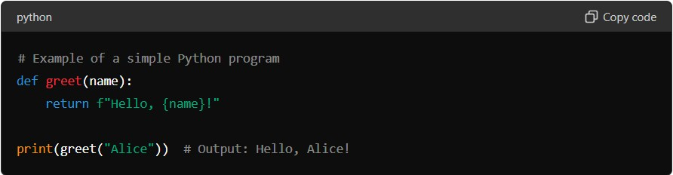
DOMAIN USAGE
Python finds application in numerous domains:
  - Web Development: Django and Flask are popular frameworks for building web applications.
  - Data Science: NumPy, Pandas, Matplotlib facilitate data manipulation, analysis, and visualization.
  - AI/ML: TensorFlow, PyTorch, scikit-learn are used for developing AI models and machine learning algorithms.
  - Automation and Scripting: Python's simplicity and extensive libraries make it ideal for automating tasks and writing scripts.
- BASIC SYNTAX AND VARIABLES
Python's syntax is designed to be clean and easy to learn, using indentation to define code structure. Variables in Python are dynamically typed, meaning their type is inferred from the value assigned. This makes Python flexible and reduces the amount of code needed for simple tasks.
Detailed Explanation:
Python's syntax:
  - Uses indentation (whitespace) to define code blocks, unlike languages that use curly braces {}.
  - Encourages clean and readable code by enforcing consistent indentation practices.
Variables in Python:
  - Dynamically typed: You don't need to declare the type of a variable explicitly.
  - Types include integers, floats, strings, lists, tuples, sets, dictionaries, etc.
Example:
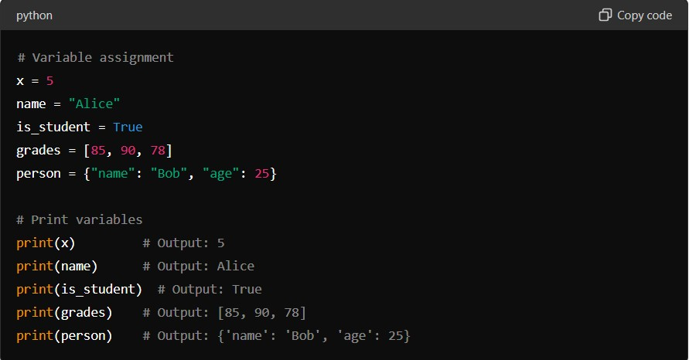
- CONTROL FLOW STATEMENTS
Control flow statements in Python determine the order in which statements are executed based on conditions or loops. Python provides several control flow constructs:
Detailed Explanation:
  - Conditional Statements (if, elif, else):
o Used for decision-making based on conditions. o Executes a block of code if a condition is true, otherwise executes another block.
Example:
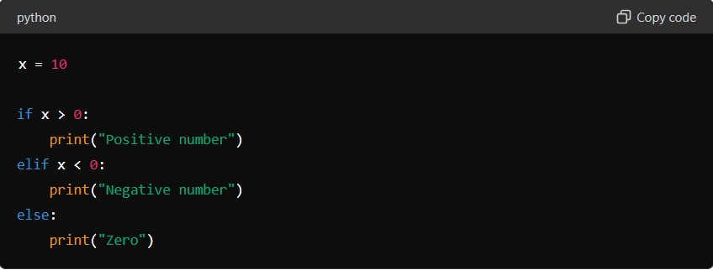

Output:
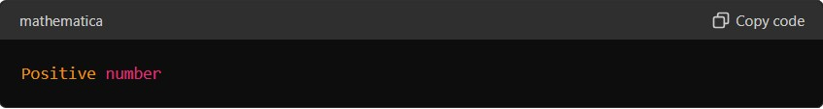

  - Loops (for and while):
    - for loop: Iterates over a sequence (e.g., list, tuple) or an iterable object.
    - while loop: Executes a block of code as long as a condition is true.
Example:
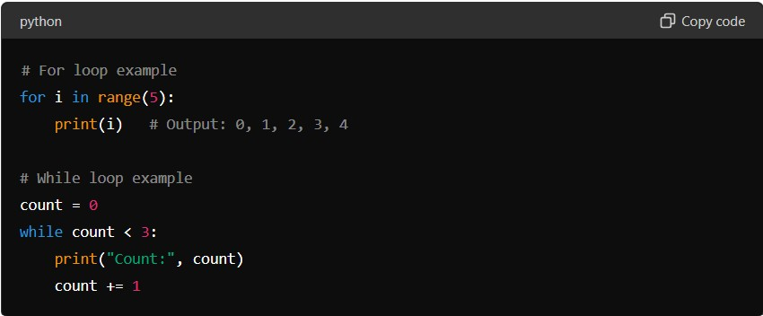
Output:
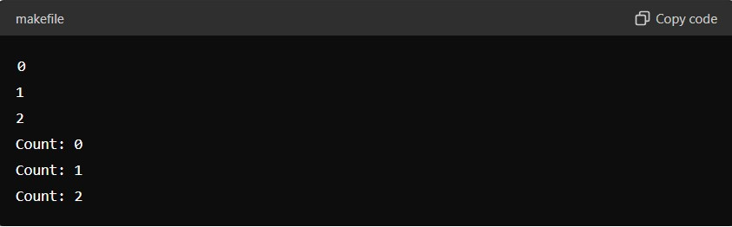
Example Explanation:
    - Conditional Statements: In Python, if statements allow you to execute a block of code only if a specified condition is true. The elif and else clauses provide additional conditions to check if the preceding conditions are false.
    - Loops: Python's for loop iterates over a sequence (e.g., a range of numbers) or an iterable object (like a list). The while loop repeats a block of code as long as a specified condition is true.
- FUNCTIONS
Functions in Python are blocks of reusable code that perform a specific task. They help in organizing code into manageable parts, promoting code reusability and modularity.
Detailed Explanation:
  - Function Definition (def keyword):
o Functions in Python are defined using the def keyword followed by the function name and parentheses containing optional parameters. o The body of the function is indented.
Example:
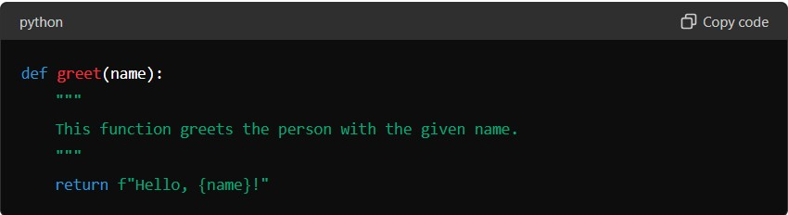
  - Function Call:
    - Functions are called or invoked by using the function name followed by parentheses containing arguments (if any).
Example:
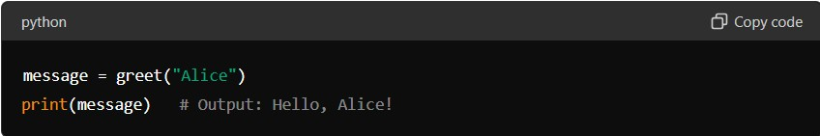
  - Parameters and Arguments:
    - Functions can accept parameters (inputs) that are specified when the function is called.
    - Parameters can have default values, making them optional.
Example:
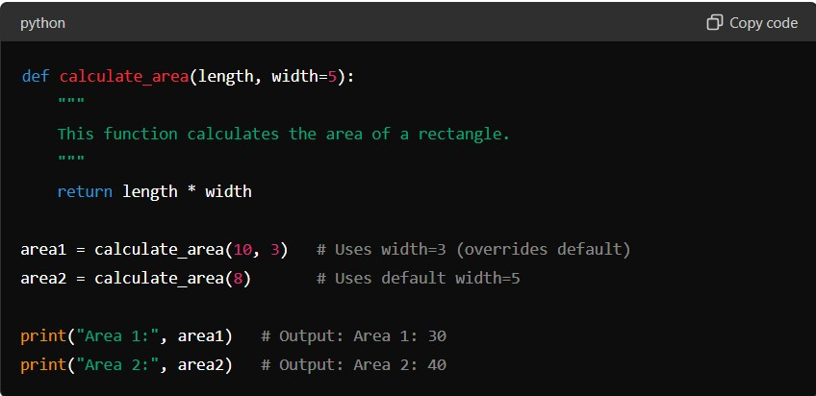
Example Explanation:
    - Function Definition: Functions are defined using def followed by the function name and parameters in parentheses. The docstring (optional) provides a description of what the function does.
    - Function Call: Functions are called by their name followed by parentheses containing arguments (if any) that are passed to the function.
    - Parameters and Arguments: Functions can have parameters with default values, allowing flexibility in function calls. Parameters are variables that hold the arguments passed to the function.
- DATA STRUCTURES
Python provides several built-in data structures that allow you to store and organize data efficiently. These include lists, tuples, sets, and dictionaries.
Detailed Explanation:
- Lists:
  - Ordered collection of items.
  - Mutable (can be modified after creation).
  - Accessed using index.
Example:
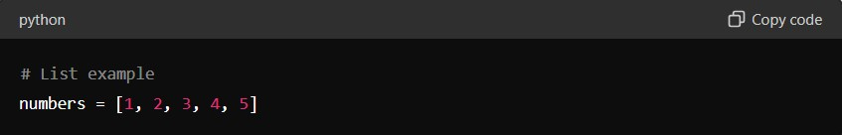
- Tuples:
  - Ordered collection of items.
  - Immutable (cannot be modified after creation).
  - Accessed using index.
Example:
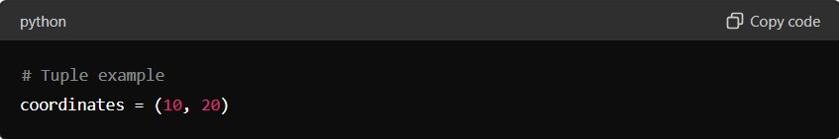
- Sets:
  - Unordered collection of unique items.
  - Mutable (can be modified after creation).
  - Cannot be accessed using index.

Example:
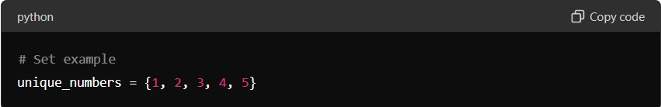
- Dictionaries:
  - Unordered collection of key-value pairs.
  - Mutable (keys are unique and values can be modified).
  - Accessed using keys.
Example:
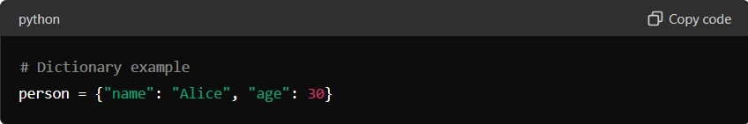
Example Explanation:
  - Lists: Used for storing ordered collections of items that can be changed or updated.
  - Tuples: Similar to lists but immutable, used when data should not change.
  - Sets: Used for storing unique items where order is not important.
  - Dictionaries: Used for storing key-value pairs, allowing efficient lookup and modification based on keys.
6. FILE HANDLING IN PYTHON:
File handling in Python allows you to perform various operations on files, such as reading from and writing to files. This is essential for tasks involving data storage and manipulation.
Detailed Explanation:
- Opening and Closing Files:
  - Files are opened using the open() function, which returns a file object.
  - Use the close() method to close the file once operations are done.
Example:
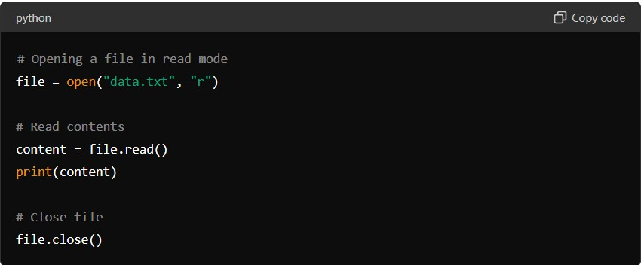
- Reading from Files:
  - Use methods like read(), readline(), or readlines() to read content from files.
  - Handle file paths and exceptions using appropriate error handling.
Example:
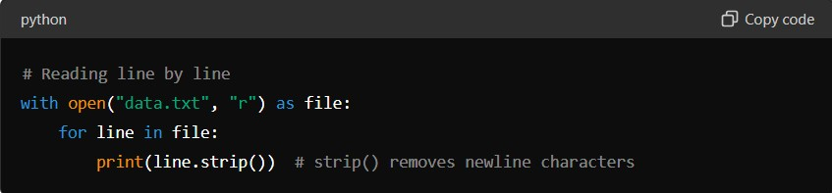
- Writing to Files:
  - Open a file in write or append mode ("w" or "a").
  - Use write() or writelines() methods to write content to the file.
Example:
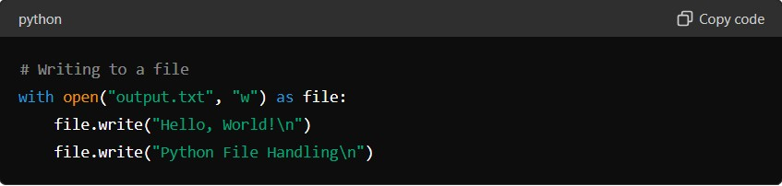
Example Explanation:
  - Opening and Closing Files: Files are opened using open() and closed using close() to release resources.
  - Reading from Files: Methods like read(), readline(), and readlines() allow reading content from files, handling file operations efficiently.
  - Writing to Files: Use write() or writelines() to write data into files, managing file contents as needed.

7. ERRORS AND EXCEPTION HANDLING
Errors and exceptions are a natural part of programming. Python provides mechanisms to handle errors gracefully, preventing abrupt termination of programs.
Detailed Explanation:
- Types of Errors:
  - Syntax Errors: Occur when the code violates the syntax rules of Python. These are detected during compilation.
  - Exceptions: Occur during the execution of a program and can be handled using exception handling.
- Exception Handling:
- Use try, except, else, and finally blocks to handle exceptions.
- try block: Contains code that might raise an exception.
- except block: Handles specific exceptions raised in the try block.
- else block: Executes if no exceptions are raised in the try block.
- finally block: Executes cleanup code, regardless of whether an exception occurred or not.
Example:
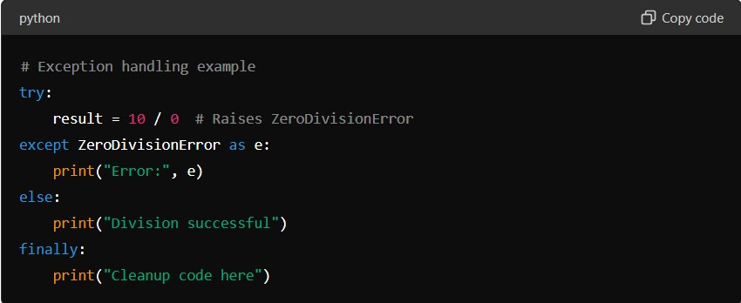
3. Raising Exceptions:
- Use raise statement to deliberately raise exceptions based on specific conditions or errors.
Example:
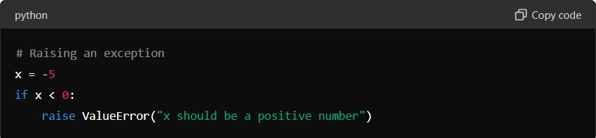
Example Explanation:
- Types of Errors: Syntax errors are caught during compilation, while exceptions occur during runtime.
- Exception Handling: try block attempts to execute code that may raise exceptions, except block catches specific exceptions, else block executes if no exceptions occur, and finally block ensures cleanup code runs regardless of exceptions.
- Raising Exceptions: Use raise to trigger exceptions programmatically based on specific conditions.

OBJECT-ORIENTED PROGRAMMING (OOP) USING PYTHON
Object-Oriented Programming (OOP) is a paradigm that allows you to structure your software in terms of objects that interact with each other. Python supports OOP principles such as encapsulation, inheritance, and polymorphism.
Detailed Explanation:
- Classes and Objects:
  - Class: Blueprint for creating objects. Defines attributes (data) and methods (functions) that belong to the class.
  - Object: Instance of a class. Represents a specific entity based on the class blueprint.
Example:
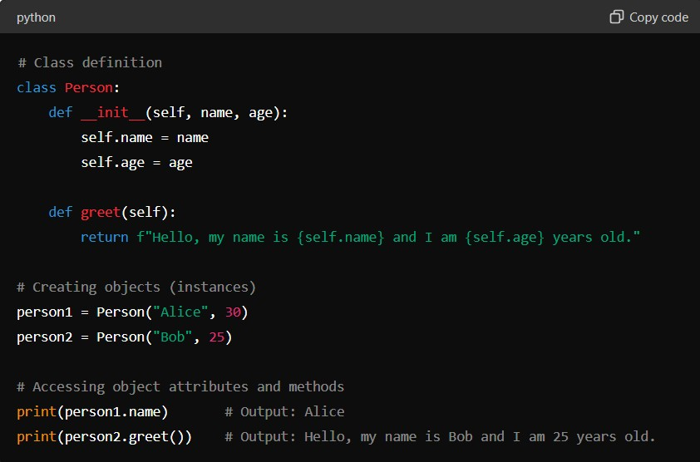
- Encapsulation:
  - Bundling of data (attributes) and methods that operate on the data into a single unit (class).
  - Access to data is restricted to methods of the class, promoting data security and integrity.
- Inheritance:
  - Ability to create a new class (derived class or subclass) from an existing class (base class or superclass).
  - Inherited class (subclass) inherits attributes and methods of the base class and can override or extend them.
Example:
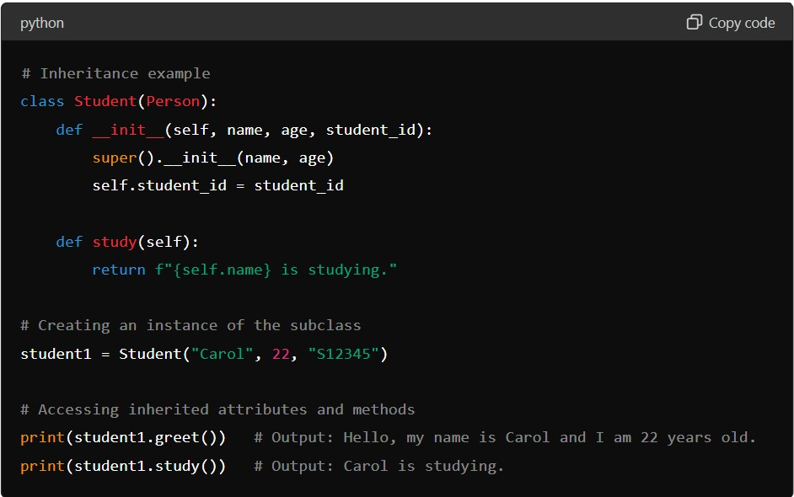
- Polymorphism:
  - Ability of objects to take on multiple forms. In Python, polymorphism is achieved through method overriding and method overloading.
  - Same method name but different implementations in different classes.
Example:
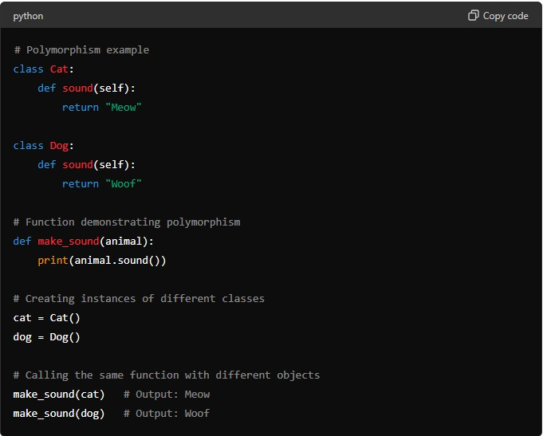
Example Explanation:
  - Classes and Objects: Classes define the structure and behavior of objects, while objects are instances of classes with specific attributes and methods.
  - Encapsulation: Keeps the internal state of an object private, controlling access through methods.
  - Inheritance: Allows a new class to inherit attributes and methods from an existing class, facilitating code reuse and extension.
  - Polymorphism: Enables flexibility by using the same interface (method name) for different data types or classes, allowing for method overriding and overloading.

PYTHON LIBRARIES FOR DATA SCIENCE
- NUMPY
NumPy (Numerical Python) is a fundamental package for scientific computing in Python. It provides support for large, multi-dimensional arrays and matrices, along with a collection of mathematical functions to operate on these arrays efficiently.
Detailed Explanation:
  - Arrays in NumPy:
      - NumPy's main object is the homogeneous multidimensional array (ndarray), which is a table of elements (usually numbers), all of the same type, indexed by a tuple of non-negative integers.
      - Arrays are created using np.array() and can be manipulated for various mathematical operations.
Example:
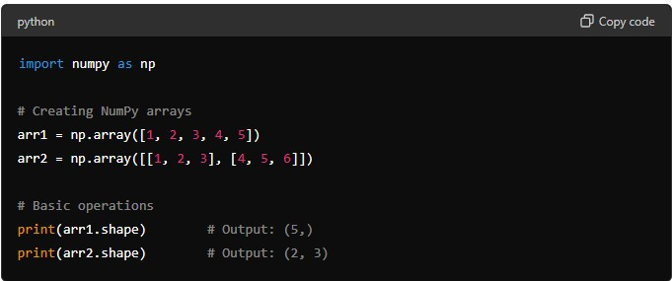
  - NumPy Operations:
o NumPy provides a wide range of mathematical functions such as np.sum(), np.mean(), np.max(), np.min(), etc., which operate element-wise on arrays or perform aggregations across axes.

Example:
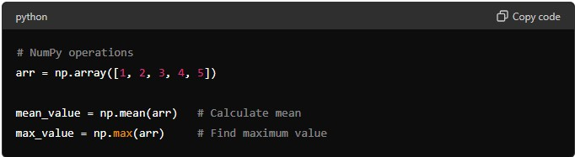
  - Broadcasting:
o Broadcasting is a powerful mechanism that allows NumPy to work with arrays of different shapes when performing arithmetic operations.
Example:
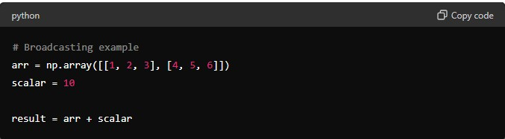
Example Explanation:
    - Arrays in NumPy: NumPy arrays are homogeneous, multidimensional data structures that facilitate mathematical operations on large datasets efficiently.
    - NumPy Operations: Use built-in functions and methods (np.sum(), np.mean(), etc.) to perform mathematical computations and aggregations on arrays.
    - Broadcasting: Automatically extends smaller arrays to perform arithmetic operations with larger arrays, enhancing computational efficiency.
- PANDAS
Pandas is a powerful library for data manipulation and analysis in Python. It provides data structures and operations for manipulating numerical tables and time series data.
Detailed Explanation:
  - DataFrame and Series:
o DataFrame: Represents a tabular data structure with labeled axes (rows and columns). It is similar to a spreadsheet or SQL table. o Series: Represents a one-dimensional labeled array capable of holding data of any type (integer, float, string, etc.).

Example:
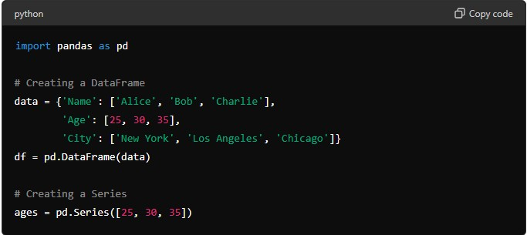
  - Basic Operations:
      - Indexing and Selection: Use loc[] and iloc[] for label-based and integer-based indexing respectively.
      - Filtering: Use boolean indexing to filter rows based on conditions.
      - Operations: Apply operations and functions across rows or columns.
Example:
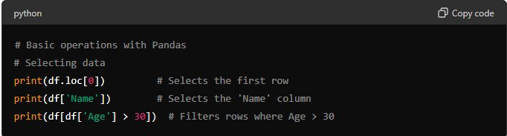
  - Data Manipulation:
o Adding and Removing Columns: Use assignment (df['New_Column'] = ...) or drop() method. o Handling Missing Data: Use dropna() to drop NaN values or fillna() to fill NaN values with specified values.
Example:
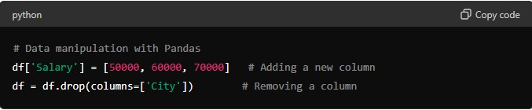
Example Explanation:
  - DataFrame and Series: Pandas DataFrame is used for tabular data, while Series is used for one-dimensional labeled data.
o Basic Operations: Perform indexing, selection, filtering, and operations on Pandas objects to manipulate and analyze data.
• Data Manipulation: Add or remove columns, handle missing data, and perform transformations using built-in Pandas methods.

📌 1. Importing Pandas
python CopyEdit
import pandas as pd

📌 2. Creating DataFrame & Series
python
CopyEdit # From dictionary
data = {'Name': ['A', 'B'], 'Age': [25, 30]} df = pd.DataFrame(data)

# From list
s = pd.Series([1, 2, 3, 4])

📌 3. Reading & Writing Files
python CopyEdit
df = pd.read_csv("file.csv") df = pd.read_excel("file.xlsx") df = pd.read_json("file.json")

df.to_csv("output.csv", index=False)

4. Basic Data Exploration

df.head() # First 5 rows df.tail(3) # Last 3 rows df.shape # (rows, columns) df.info() # Data types & nulls df.describe() # Summary statistics df.columns # Column names df.dtypes # Column data types

📌 5. Selecting Data
python CopyEdit
df['Age'] # Single column df[['Name', 'Age']] # Multiple columns

df.iloc[0] # First row by index df.iloc[0:2] # First 2 rows

df.loc[0, 'Name'] # Row 0, column 'Name' df.loc[:, 'Age'] # All rows, column 'Age'

📌 6. Filtering Rows
python CopyEdit df[df['Age'] > 25]
df[(df['Age'] > 25) & (df['Gender'] == 'M')]

📌 7. Adding & Dropping Columns
python CopyEdit df['NewCol'] = df['Age'] + 5 # Add new column df.drop('NewCol', axis=1, inplace=True) # Drop column

📌 8. Handling Missing Data
python CopyEdit df.isnull().sum() # Count missing df.dropna() # Drop rows with missing df.fillna(0) # Fill missing with 0 df.fillna(method='ffill') # Forward fill

📌 9. Renaming Columns
python CopyEdit
df.rename(columns={'OldName': 'NewName'}, inplace=True)

📌 10. Sorting Data
python CopyEdit df.sort_values(by='Age')
df.sort_values(by=['Age', 'Name'], ascending=[True, False])

📌 11. Grouping and Aggregation
python CopyEdit
df.groupby('Gender').mean()
df.groupby('Gender').agg({'Age': 'mean', 'Salary': 'sum'})

12. Merging, Joining, Concatenating

pd.merge(df1, df2, on='ID', how='inner') # Merge

df_all = pd.concat([df1, df2]) # Concatenate

📌 13. Pivot Table
python CopyEdit
df.pivot_table(index='Department', columns='Gender', values='Salary', aggfunc='mean')

📌 14. Apply Functions
python CopyEdit df['AgeSquared'] = df['Age'].apply(lambda x: x**2)

def age_category(age):
return 'Adult' if age > 18 else 'Child'

df['Category'] = df['Age'].apply(age_category)

📌 15. Iterating through Rows
python CopyEdit for index, row in df.iterrows():
print(index, row['Name'], row['Age'])

16. Data Type Conversion

df['Age'] = df['Age'].astype(float) pd.to_datetime(df['Date'])

📌 17. Datetime Operations
python CopyEdit
df['Date'] = pd.to_datetime(df['Date']) df['Year'] = df['Date'].dt.year df['Month'] = df['Date'].dt.month

📌 18. Detecting Duplicates
python CopyEdit df.duplicated().sum()
df.drop_duplicates(inplace=True)

📌 19. Normalization & Scaling
python CopyEdit
from sklearn.preprocessing import MinMaxScaler, StandardScaler

scaler = MinMaxScaler()
df_scaled = pd.DataFrame(scaler.fit_transform(df), columns=df.columns)

20. Outlier Detection & Handling (IQR Method)

Q1 = df['Age'].quantile(0.25)
Q3 = df['Age'].quantile(0.75)
IQR = Q3 - Q1

lower = Q1 - 1.5 * IQR upper = Q3 + 1.5 * IQR

df['Age'] = df['Age'].apply(lambda x: df['Age'].mean() if x < lower or x > upper else x)

- MATPLOTLIB AND SEABORN
Matplotlib is a comprehensive library for creating static, animated, and interactive visualizations in Python. Seaborn is built on top of Matplotlib and provides a higher-level interface for drawing attractive and informative statistical graphics.
Detailed Explanation:
  - Matplotlib:
      - Basic Plotting: Create line plots, scatter plots, bar plots, histograms, etc., using plt.plot(), plt.scatter(), plt.bar(), plt.hist(), etc.
      - Customization: Customize plots with labels, titles, legends, colors, markers, and other aesthetic elements. o Subplots: Create multiple plots within the same figure using plt.subplots().
Example:
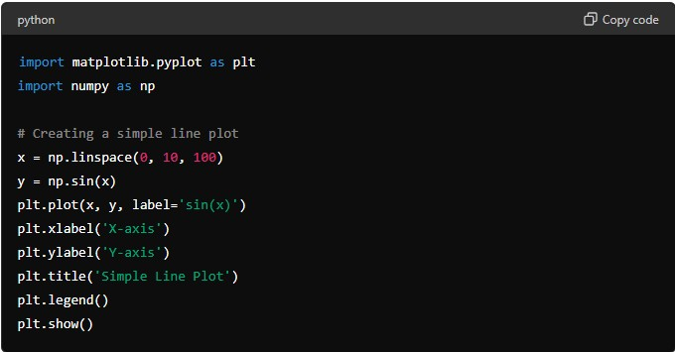
  - Seaborn:
      - Statistical Plots: Easily create complex statistical visualizations like violin plots, box plots, pair plots, etc., with minimal code.
      - Aesthetic Enhancements: Seaborn enhances Matplotlib plots with better aesthetics and default color palettes.
      - Integration with Pandas: Seaborn integrates seamlessly with Pandas DataFrames for quick and intuitive data visualization.
Example:
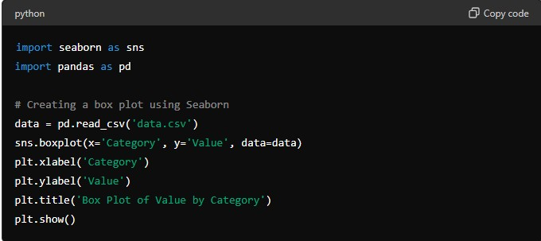
Example Explanation:
  - Matplotlib: Create various types of plots and customize them using Matplotlib's extensive API for visualization.
  - Seaborn: Build complex statistical plots quickly and easily, leveraging Seaborn's highlevel interface and aesthetic improvements.
MACHINE LEARNING
INTRODUCTION TO MACHINE LEARNING
Machine Learning (ML) is a branch of artificial intelligence (AI) that empowers computers to learn from data and improve their performance over time without explicit programming. It focuses on developing algorithms that can analyze and interpret patterns in data to make predictions or decisions.
Detailed Explanation:
1. Types of Machine Learning o Supervised Learning: Learns from labeled data, making predictions or decisions based on input-output pairs.
      - Unsupervised Learning: Extracts patterns from unlabeled data, identifying hidden structures or relationships.
      - Reinforcement Learning: Trains models to make sequences of decisions, learning through trial and error with rewards or penalties.

      - Semi-Supervised Learning: Uses a combination of labeled and unlabeled data for training.
2. Applications of Machine Learning o Natural Language Processing (NLP): Speech recognition, language translation, sentiment analysis.
      - Computer Vision: Object detection, image classification, facial recognition. o Healthcare: Disease diagnosis, personalized treatment plans, medical image analysis.
      - Finance: Fraud detection, stock market analysis, credit scoring.
      - Recommendation Systems: Product recommendations, content filtering, personalized marketing.
  - Machine Learning vs. Data Science o Machine Learning: Focuses on algorithms and models to make predictions or decisions based on data.
o Data Science: Broader field encompassing data collection, cleaning, analysis, visualization, and interpretation to derive insights and make informed decisions.
- Machine Learning vs. Deep Learning o Machine Learning: Relies on algorithms and statistical models to perform tasks; requires feature engineering and domain expertise.
o Deep Learning: Subset of ML using artificial neural networks with multiple layers to learn representations of data; excels in handling large volumes of data and complex tasks like image and speech recognition.
SUPERVISED MACHINE LEARNING
Supervised learning involves training a model on labeled data, where each data point is paired with a corresponding target variable (label). The goal is to learn a mapping from input variables (features) to the output variable (target) based on the input-output pairs provided during training.
Classification
Definition: Classification is a type of supervised learning where the goal is to predict discrete class labels for new instances based on past observations with known class labels.
Algorithms:
    - Logistic Regression: Estimates probabilities using a logistic function.
    - Decision Trees: Hierarchical tree structures where nodes represent decisions based on feature values.
    - Random Forest: Ensemble of decision trees to improve accuracy and reduce overfitting.
    - Support Vector Machines (SVM): Finds the optimal hyperplane that best separates classes in high-dimensional space.
    - k-Nearest Neighbors (k-NN): Classifies new instances based on similarity to known examples
- Logistic Regression
  - Definition: Despite its name, logistic regression is a linear model for binary classification that uses a logistic function to estimate probabilities.
  - Key Concepts:
    - Logistic Function: Sigmoid function that maps input values to probabilities between 0 and 1.
    - Decision Boundary: Threshold that separates the classes based on predicted probabilities.
: 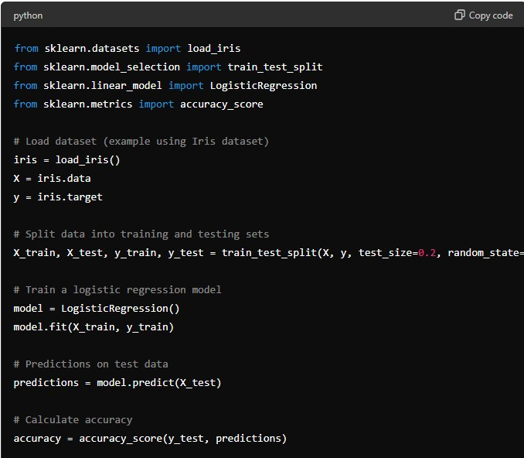
- Decision Trees
  - Definition: Non-linear model that uses a tree structure to make decisions by splitting the data into nodes based on feature values.
  - Key Concepts:
    - Nodes and Branches: Represent conditions and possible outcomes in the decision-making process.
    - Entropy and Information Gain: Measures used to determine the best split at each node.
Example:
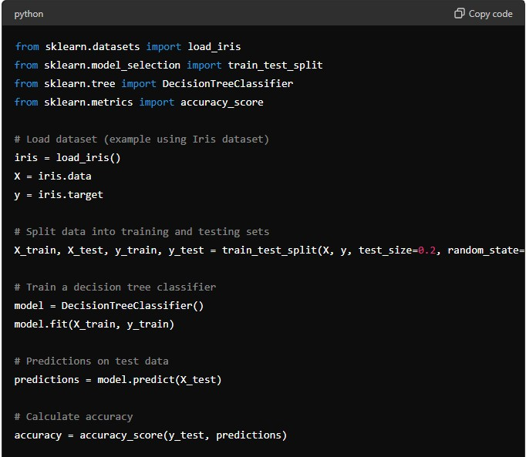
- Random Forest
  - Definition: Ensemble learning method that constructs multiple decision trees during training and outputs the mode of the classes (classification) or mean prediction (regression) of the individual trees.
  - Key Concepts:
    - Bagging: Technique that combines multiple models to improve performance and reduce overfitting.
    - Feature Importance: Measures the contribution of each feature to the model's predictions.
Example:
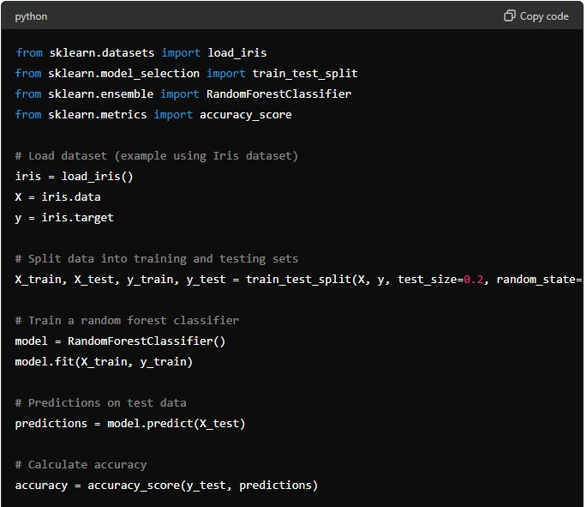
- Support Vector Machines (Svm)
Support Vector Machines (SVM) are robust supervised learning models used for classification and regression tasks. They excel in scenarios where the data is not linearly separable by transforming the input space into a higher dimension.
Detailed Explanation:
1. Basic Concepts of SVM o Hyperplane: SVMs find the optimal hyperplane that best separates classes in a high-dimensional space.
    - Support Vectors: Data points closest to the hyperplane that influence its position and orientation.
    - Kernel Trick: Technique to transform non-linearly separable data into linearly separable data using kernel functions (e.g., polynomial, radial basis function (RBF)).

2. Types of SVM o C-Support Vector Classification (SVC): SVM for classification tasks, maximizing the margin between classes.
    - Nu-Support Vector Classification (NuSVC): Similar to SVC but allows control over the number of support vectors and training errors.
    - Support Vector Regression (SVR): SVM for regression tasks, fitting a hyperplane within a margin of tolerance.
Example (SVM for Classification):
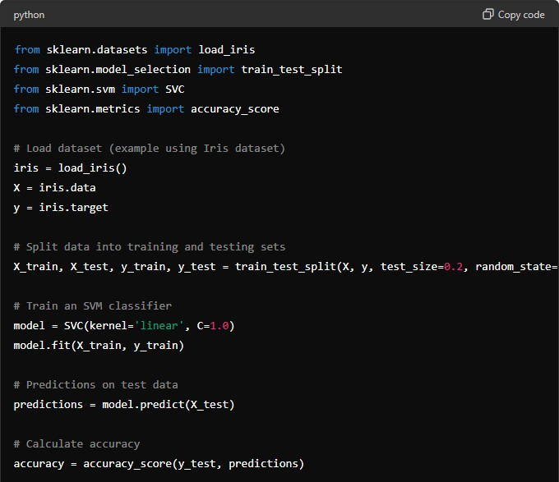
- Advantages of SVM
  - Effective in High-Dimensional Spaces: Handles datasets with many features (dimensions).
  - Versatile Kernel Functions: Can model non-linear decision boundaries using different kernel functions.
  - Regularization Parameter (C): Controls the trade-off between maximizing the margin and minimizing classification errors.
- Applications of SVM
  - Text and Hypertext Categorization: Document classification, spam email detection.
  - Image Recognition: Handwritten digit recognition, facial expression classification.
  - Bioinformatics: Protein classification, gene expression analysis.
Hyperplane and Support Vectors: SVMs find the optimal hyperplane that maximizes the margin between classes, with support vectors influencing its position.
Kernel Trick: Transforms data into higher dimensions to handle non-linear separability, improving classification accuracy.
Applications: SVMs are applied in diverse fields for classification tasks requiring robust performance and flexibility in handling complex data patterns.

- Decision Trees
Decision Trees are versatile supervised learning models used for both classification and regression tasks. They create a tree-like structure where each internal node represents a "decision" based on a feature, leading to leaf nodes that represent the predicted outcome.
Detailed Explanation:
  - Basic Concepts of Decision Trees o Nodes and Branches: Nodes represent features or decisions, and branches represent possible outcomes or decisions.
      - Splitting Criteria: Algorithms choose the best feature to split the data at each node based on metrics like Gini impurity or information gain.
      - Tree Pruning: Technique to reduce the size of the tree to avoid overfitting.
  - Types of Decision Trees o Classification Trees: Predicts discrete class labels for new data points.
o Regression Trees: Predicts continuous numeric values for new data points.
Example (Decision Tree for Classification):
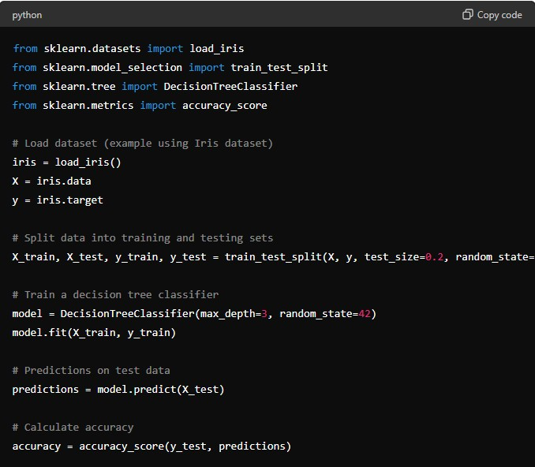
  - Advantages of Decision Trees
    - Interpretability: Easy to interpret and visualize, making it useful for exploratory data analysis.
    - Handles Non-linearity: Can capture non-linear relationships between features and target variables.
    - Feature Importance: Automatically selects the most important features for prediction.
  - Applications of Decision Trees
    - Finance: Credit scoring, loan default prediction.
    - Healthcare: Disease diagnosis based on symptoms.
    - Marketing: Customer segmentation, response prediction to marketing campaigns.
Regression Analysis
1. Linear Regression
Linear Regression is a fundamental supervised learning algorithm used for predicting continuous numeric values based on input features. It assumes a linear relationship between the input variables (features) and the target variable.
Detailed Explanation:
- Basic Concepts of Linear Regression
  - Linear Model: Represents the relationship between the input features XXX and the target variable yyy using a linear equation.
  - Coefficients: Slope coefficients β\betaβ that represent the impact of each feature on the target variable.
  - Intercept: Constant term β0\beta_0β0 that shifts the regression line.
- Types of Linear Regression
  - Simple Linear Regression: Predicts a target variable using a single input feature.
  - Multiple Linear Regression: Predicts a target variable using multiple input features.
- Assumptions of Linear Regression
  - Linearity: Assumes a linear relationship between predictors and the target variable.
  - Independence of Errors: Residuals (errors) should be independent of each other.
  - Homoscedasticity: Residuals should have constant variance across all levels of predictors.

Example (Simple Linear Regression):
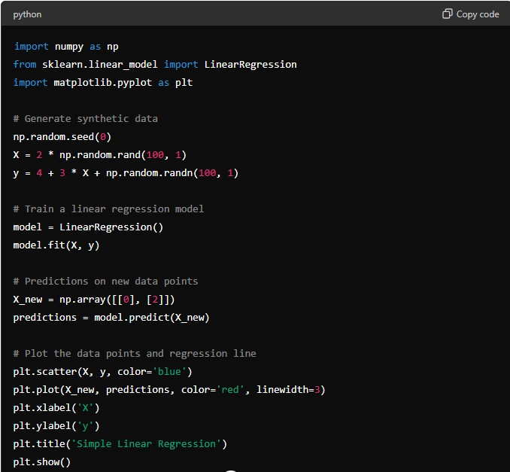
  - Advantages of Linear Regression
    - Interpretability: Easy to interpret coefficients and understand the impact of predictors.
    - Computational Efficiency: Training and prediction times are generally fast.
    - Feature Importance: Identifies which features are most influential in predicting the target variable.
5. Applications of Linear Regression
    - Economics: Predicting GDP growth based on economic indicators.
    - Marketing: Predicting sales based on advertising spend.
    - Healthcare: Predicting patient outcomes based on medical data.
- Naive Bayes
Naive Bayes is a probabilistic supervised learning algorithm based on Bayes' theorem, with an assumption of independence between features. It is commonly used for classification tasks and is known for its simplicity and efficiency, especially with high-dimensional data.
Detailed Explanation:
  - Basic Concepts of Naive Bayes o Bayes' Theorem: Probabilistic formula that calculates the probability of a hypothesis based on prior knowledge.
    - Independence Assumption: Assumes that the features are conditionally independent given the class label.
    - Posterior Probability: Probability of a class label given the features.
  - Types of Naive Bayes o Gaussian Naive Bayes: Assumes that continuous features follow a Gaussian distribution.

Multinomial Naive Bayes: Suitable for discrete features (e.g., word counts in text classification). o Bernoulli Naive Bayes: Assumes binary or boolean features (e.g., presence or absence of a feature).
Example (Gaussian Naive Bayes):
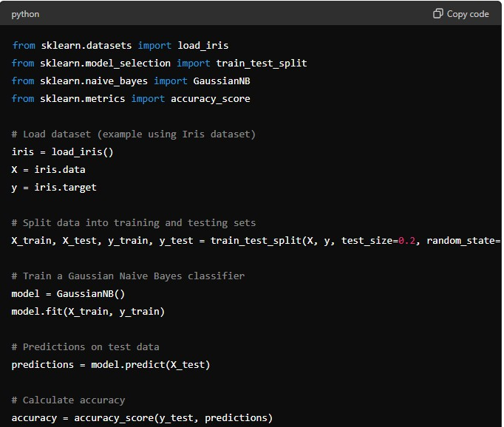
- Advantages of Naive Bayes
  - Efficiency: Fast training and prediction times, especially with large datasets.
  - Simplicity: Easy to implement and interpret, making it suitable for baseline classification tasks.
  - Scalability: Handles high-dimensional data well, such as text classification.
- Applications of Naive Bayes
  - Text Classification: Spam detection, sentiment analysis.
  - Medical Diagnosis: Disease prediction based on symptoms.
  - Recommendation Systems: User preferences prediction.
- Support Vector Machines (Svm) For Regression
Support Vector Machines (SVM) are versatile supervised learning models that can be used for both classification and regression tasks. In regression, SVM aims to find a hyperplane that best fits the data, while maximizing the margin from the closest points (support vectors).
Detailed Explanation:
  - Basic Concepts of SVM for Regression o Kernel Trick: SVM can use different kernel functions (linear, polynomial, radial basis function) to transform the input space into a higher-dimensional space where a linear hyperplane can separate the data.
    - Loss Function: SVM minimizes the error between predicted values and actual values, while also maximizing the margin around the hyperplane.
  - Mathematical Formulation o SVM for regression predicts the target variable yyy for an instance X using a linear function
Example (Support Vector Machines for Regression):
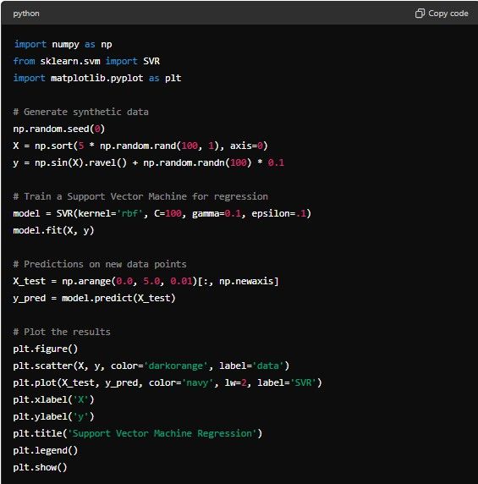
  - Advantages of SVM for Regression
    - Effective in High-Dimensional Spaces: SVM can handle data with many features (high-dimensional spaces).
    - Robust to Overfitting: SVM uses a regularization parameter CCC to control overfitting.
Versatility: Can use different kernel functions to model non-linear relationships in data.
4.Applications of SVM for Regression
    - Stock Market Prediction: Predicting stock prices based on historical data. o Economics: Forecasting economic indicators like GDP growth. o Engineering: Predicting equipment failure based on sensor data.
Example Explanation:

Kernel Trick: SVM uses kernel functions to transform the input space into a higherdimensional space where data points can be linearly separated.

Loss Function: SVM minimizes the error between predicted and actual values while maximizing the margin around the hyperplane.
 Applications: SVM is widely used in regression tasks where complex relationships between variables need to be modeled effectively.

- Random Forest For Regression
Random Forest is an ensemble learning method that constructs multiple decision trees during training and outputs the average prediction of the individual trees for regression tasks.
Detailed Explanation:
  - Basic Concepts of Random Forest o Ensemble Learning: Combines multiple decision trees to improve generalization and robustness over a single tree.
    - Bagging: Random Forest uses bootstrap aggregating (bagging) to train each tree on a random subset of the data.
    - Decision Trees: Each tree in the forest is trained on a different subset of the data and makes predictions independently.
  - Random Forest Algorithm o Tree Construction: Random Forest builds multiple decision trees, where each tree is trained on a random subset of features and data points.
    - Prediction: For regression, Random Forest averages the predictions of all trees to obtain the final output.
Example (Random Forest for Regression):
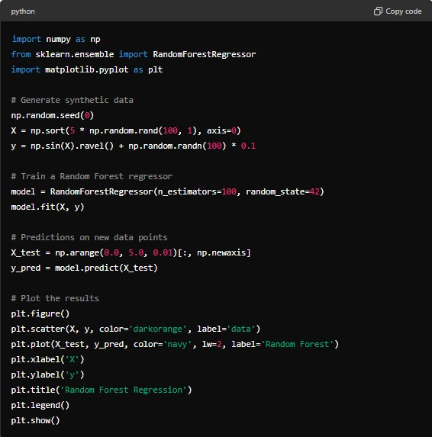
Example Explanation:
  - Ensemble Learning: Random Forest combines multiple decision trees to obtain a more accurate and stable prediction.
  - Feature Importance: Random Forest calculates feature importance scores, allowing analysts to understand which variables are most influential in making predictions.
  - Applications: Random Forest is widely used in various domains for regression tasks where accuracy and robustness are crucial.

UNSUPERVISED MACHINE LEARNING
INTRODUCTION TO UNSUPERVISED LEARNING
Unsupervised learning algorithms are used when we only have input data (X) and no corresponding output variables. The algorithms learn to find the inherent structure in the data, such as grouping or clustering similar data points together.
Detailed Explanation:
1. Basic Concepts of Unsupervised Learning
No Target Variable: Unlike supervised learning, unsupervised learning does not require labeled data.
    - Exploratory Analysis: Unsupervised learning helps in exploring data to understand its characteristics and patterns.
    - Types of Tasks: Common tasks include clustering similar data points together or reducing the dimensionality of the data.
2. Types of Unsupervised Learning Tasks o Clustering: Grouping similar data points together based on their features or similarities.
    - Dimensionality Reduction: Reducing the number of variables under consideration by obtaining a set of principal variables.
  - Algorithms in Unsupervised Learning o Clustering Algorithms: Such as K-Means, Hierarchical Clustering, DBSCAN. o Dimensionality Reduction Techniques: Like Principal Component Analysis (PCA), t-Distributed Stochastic Neighbor Embedding (t-SNE).
  - Applications of Unsupervised Learning o Customer Segmentation: Grouping customers based on their purchasing behaviors.
    - Anomaly Detection: Identifying unusual patterns in data that do not conform to expected behavior.
    - Recommendation Systems: Suggesting items based on user preferences and similarities.
Dimensionality Reduction Techniques
Principal Component Analysis (Pca)
Principal Component Analysis (PCA) is a dimensionality reduction technique used to transform high-dimensional data into a lower-dimensional space while preserving the most important aspects of the original data.
Detailed Explanation:
1. Basic Concepts of PCA o Dimensionality Reduction: Reduces the number of features (dimensions) in the data while retaining as much variance as possible.
    - Eigenvalues and Eigenvectors: PCA identifies the principal components (eigenvectors) that capture the directions of maximum variance in the data.
    - Variance Explanation: Each principal component explains a certain percentage of the variance in the data.
2. PCA Algorithm o Step-by-Step Process:
      - Standardize the data (mean centering and scaling).
      - Compute the covariance matrix of the standardized data.
      - Calculate the eigenvectors and eigenvalues of the covariance matrix.
      - Select the top kkk eigenvectors (principal components) that explain the most variance.
      - Project the original data onto the selected principal components to obtain the reduced-dimensional representation.
Example (PCA):
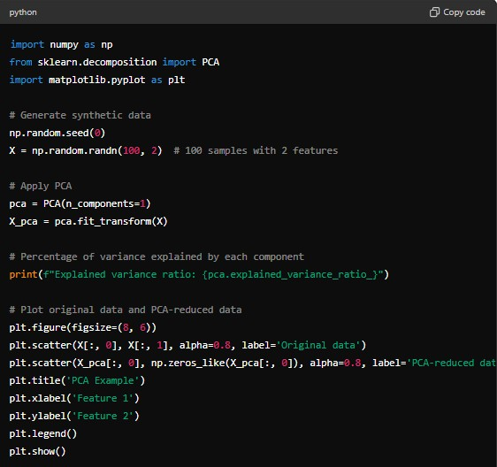

- Advantages of PCA
      - Dimensionality Reduction: Reduces the computational complexity and storage space needed for processing data.
      - Feature Interpretability: PCA transforms data into a new space where features are uncorrelated (orthogonal).
      - Noise Reduction: Focuses on capturing the largest sources of variance, effectively filtering out noise.

4.Applications of PCA
      - Image Compression: Reduce the dimensionality of image data while retaining important features.
      - Bioinformatics: Analyze gene expression data to identify patterns and reduce complexity.
      - Market Research: Analyze customer purchase behavior across multiple product categories.
Clustering techniques
K-Means Clustering
K-Means clustering is a popular unsupervised learning algorithm used for partitioning a dataset into K distinct, non-overlapping clusters.
Detailed Explanation:
  - Basic Concepts of K-Means Clustering o Objective: Minimize the variance within each cluster and maximize the variance between clusters.
      - Centroid-Based: Each cluster is represented by its centroid, which is the mean of the data points assigned to the cluster.
      - Distance Measure: Typically uses Euclidean distance to assign data points to clusters.
  - K-Means Algorithm
      - Initialization: Randomly initialize K centroids.
      - Assignment: Assign each data point to the nearest centroid based on distance (typically Euclidean distance).
      - Update Centroids: Recalculate the centroids as the mean of all data points assigned to each centroid.
      - Iterate: Repeat the assignment and update steps until convergence (when centroids no longer change significantly or after a specified number of iterations).
Example (K-Means Clustering):
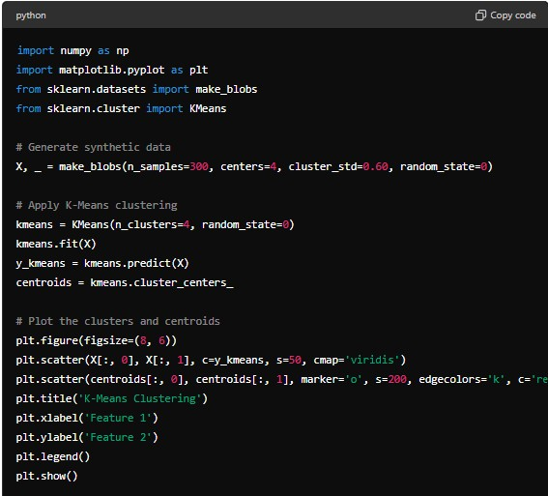
3.Advantages of K-Means Clustering
    - Simple and Efficient: Easy to implement and computationally efficient for large datasets.
    - Scalable: Scales well with the number of data points and clusters.
    - Interpretability: Provides interpretable results by assigning each data point to a cluster.
- Applications of K-Means Clustering
    - Customer Segmentation: Grouping customers based on purchasing behavior for targeted marketing.
    - Image Segmentation: Partitioning an image into regions based on color similarity.
    - Anomaly Detection: Identifying outliers or unusual patterns in data.

Hierarchical Clustering
Hierarchical Clustering is an unsupervised learning algorithm that groups similar objects into clusters based on their distances or similarities.
Detailed Explanation:
- Basic Concepts of Hierarchical Clustering o Agglomerative vs. Divisive:
    - Agglomerative: Starts with each data point as a singleton cluster and iteratively merges the closest pairs of clusters until only one cluster remains.
    - Divisive: Starts with all data points in one cluster and recursively splits them into smaller clusters until each cluster contains only one data point.
  - Distance Measures: Uses measures like Euclidean distance or correlation to determine the similarity between data points.
- Hierarchical Clustering Algorithm o Distance Matrix: Compute a distance matrix that measures the distance between each pair of data points.
  - Merge or Split: Iteratively merge or split clusters based on their distances until the desired number of clusters is achieved or a termination criterion is met.
  - Dendrogram: Visual representation of the clustering process, showing the order and distances of merges or splits.
Example (Hierarchical Clustering):
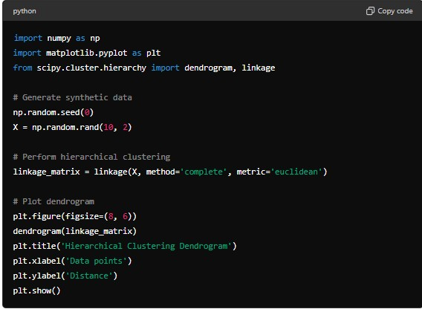
- Advantages of Hierarchical Clustering
  - No Need to Specify Number of Clusters: Hierarchical clustering does not require the number of clusters to be specified beforehand.
  - Visual Representation: Dendrogram provides an intuitive visual representation of the clustering hierarchy.
  - Cluster Interpretation: Helps in understanding the relationships and structures within the data.
- Applications of Hierarchical Clustering
  - Biology: Grouping genes based on expression levels for studying genetic relationships.
  - Document Clustering: Organizing documents based on similarity of content.
  - Market Segmentation: Segmenting customers based on purchasing behavior for targeted marketing strategies.

MODULE 3 – SQL FOR DATA SCIENCE
- INTRODUCTION TO SQL
SQL (Structured Query Language) is a standard language for managing and manipulating relational databases. It is essential for data scientists to retrieve, manipulate, and analyze data stored in databases.
Detailed Explanation:
- Basic SQL Commands:
  - SELECT: Retrieves data from a database.
Example:
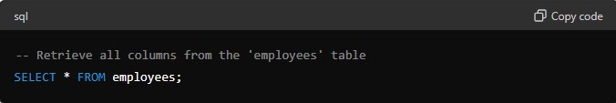*
  - INSERT: Adds new rows of data into a database table.
Example:
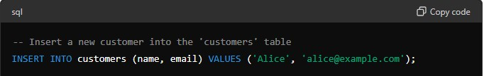
  - UPDATE: Modifies existing data in a database table.
Example:
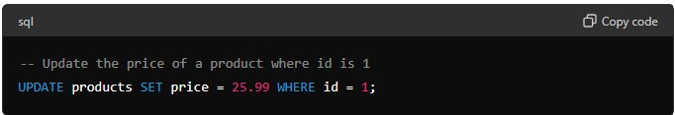
  - DELETE: Removes rows from a database table.
Example:
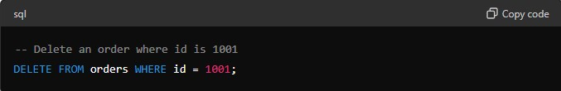
- Querying Data:
  - Use SELECT statements with conditions (WHERE), sorting (ORDER BY), grouping (GROUP BY), and aggregating functions (COUNT, SUM, AVG) to retrieve specific data subsets.
Example:
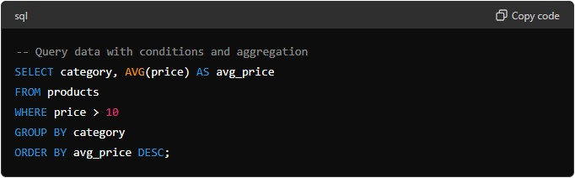
- TYPES OF SQL JOINS
SQL joins are used to combine rows from two or more tables based on a related column between them. There are different types of joins:
  - INNER JOIN: o Returns rows when there is a match in both tables based on the join condition. Example:
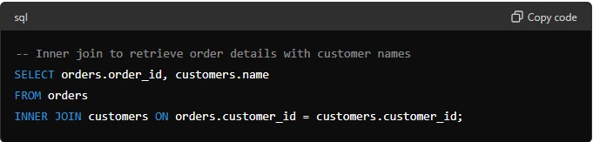
  - LEFT JOIN (or LEFT OUTER JOIN):
    - Returns all rows from the left table (orders), and the matched rows from the right table (customers). If there is no match, NULL values are returned from the right side.
Example:
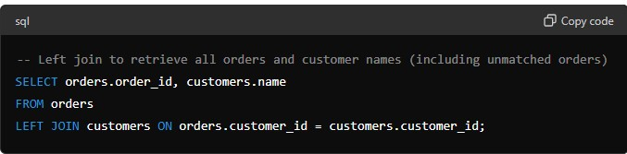
  - RIGHT JOIN (or RIGHT OUTER JOIN):
    - Returns all rows from the right table (customers), and the matched rows from the left table (orders). If there is no match, NULL values are returned from the left side.
Example:
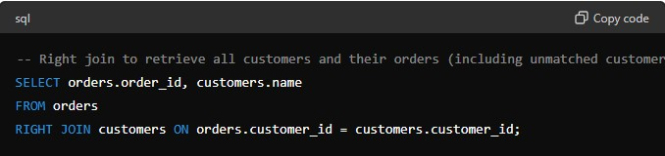
  - FULL OUTER JOIN:
    - Returns all rows when there is a match in either left table (orders) or right table (customers). If there is no match, NULL values are returned from the opposite side.
Example:
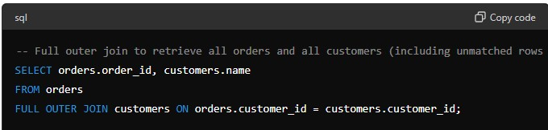
Example Explanation:
  - INNER JOIN: Returns rows where there is a match in both tables based on the join condition (customer_id).
  - LEFT JOIN: Returns all rows from the left table (orders) and the matched rows from the right table (customers). Returns NULL if there is no match.
  - RIGHT JOIN: Returns all rows from the right table (customers) and the matched rows from the left table (orders). Returns NULL if there is no match.
  - FULL OUTER JOIN: Returns all rows when there is a match in either table (orders or customers). Returns NULL if there is no match.

Advanced SQL Concepts
- Window Functions
Window functions allow performing calculations across a set of table rows related to the current row while retaining individual row details.
Types of Window Functions:
  - Ranking Functions: ROW_NUMBER(), RANK(), DENSE_RANK(), NTILE(n)
  - Aggregate Window Functions: SUM(), AVG(), COUNT(), MAX(), MIN()
  - Value Functions: LEAD(), LAG(), FIRST_VALUE(), LAST_VALUE()
Example:
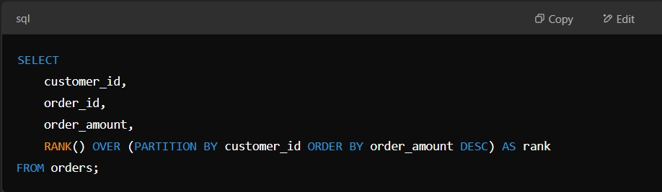
This ranks orders per customer based on order amount.
- Common Table Expressions (CTEs)
CTEs allow defining a temporary result set that can be referenced within a SQL statement, improving query readability.
Example:
This finds customers who spent more than $500
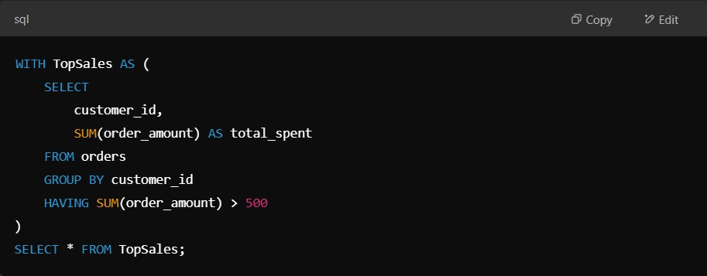
- Subqueries
A subquery (nested query) is a query inside another SQL query. It helps retrieve data dynamically.
Types of Subqueries:
- Scalar Subquery (returns a single value)
- Multi-row Subquery (returns multiple rows)
- Correlated Subquery (depends on outer query)
Example: This fetches orders where the amount is greater than the average order amount.
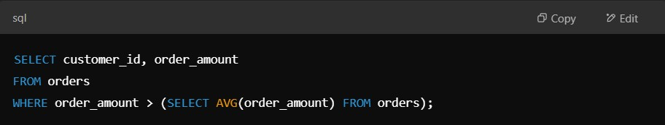
- Indexing in SQL
Indexes improve query performance by allowing faster data retrieval.
Types of Indexes:
  - Primary Index (Automatically created on primary key)
  - Unique Index (Ensures uniqueness in columns)
  - Clustered & Non-Clustered Indexes
Example: This creates an index on the customer_id column.
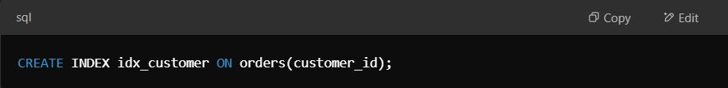
- SQL Transactions & ACID Properties
Transactions ensure the database maintains integrity using ACID properties (Atomicity, Consistency, Isolation, Durability).
Example:
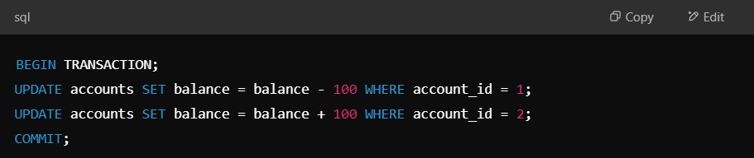
Ensures money transfer happens completely or not at all.
MODULE 4 – MICROSOFT POWER BI What is Power BI?

Power BI is a business intelligence (BI) tool developed by Microsoft that enables users to connect, transform, visualize, and share data easily. It helps in making data-driven decisions through interactive reports and dashboards.
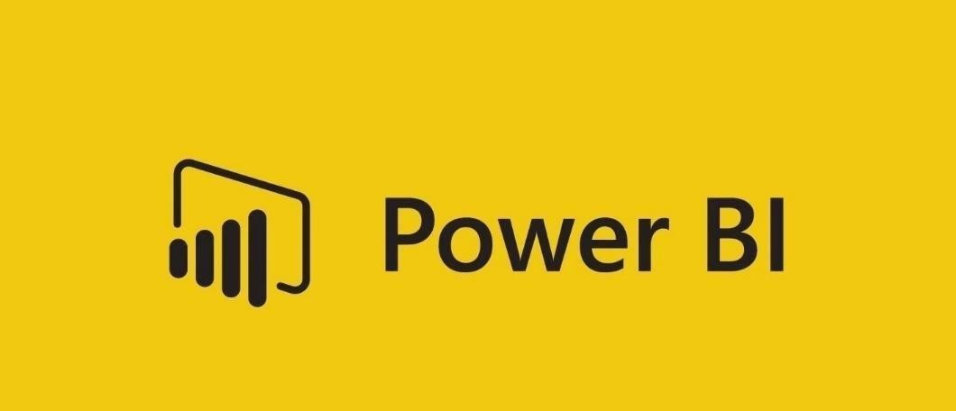

Key Components of Power BI

Power BI consists of several components:

- Power BI Desktop – A Windows application for creating reports and dashboards.

- Power BI Service (Power BI Online) – A cloud-based platform for sharing and collaborating on reports.

- Power BI Mobile – A mobile app for accessing dashboards and reports on the go.

- Power BI Report Server – An on-premises solution for hosting and sharing reports.

- Power BI Gateway – A tool that connects cloud-based Power BI with on-premises data sources.

Why Use Power BI?
  - Easy Data Connectivity: Connects with multiple sources (Excel, SQL, Google Analytics, etc.).

  - Powerful Visualizations: Offers a wide range of charts, graphs, and interactive elements.

  - AI-Powered Insights: Uses machine learning for trend analysis and forecasting.

  - Self-Service BI: Allows users to analyze data without deep technical expertise.

  - Seamless Integration: Works well with Microsoft tools (Excel, Azure, PowerApps). Power BI vs. Other BI Tools

Feature | Power BI | Tableau | Excel
Ease of Use | High | Medium | High
Cost | Affordable | Expensive | Low
AI Features | Yes | Limited | No
Cloud Support | Strong | Strong | Weak
Where is Power BI Used?
Power BI is used across industries for:

- Finance: Budgeting, forecasting, and financial reporting.

- Healthcare: Patient data analysis and operational performance.

- Retail: Sales performance and inventory management.

- Marketing: Customer insights and campaign analysis.

- IT & Operations: Monitoring system performance and user analytics.

Power BI Architecture
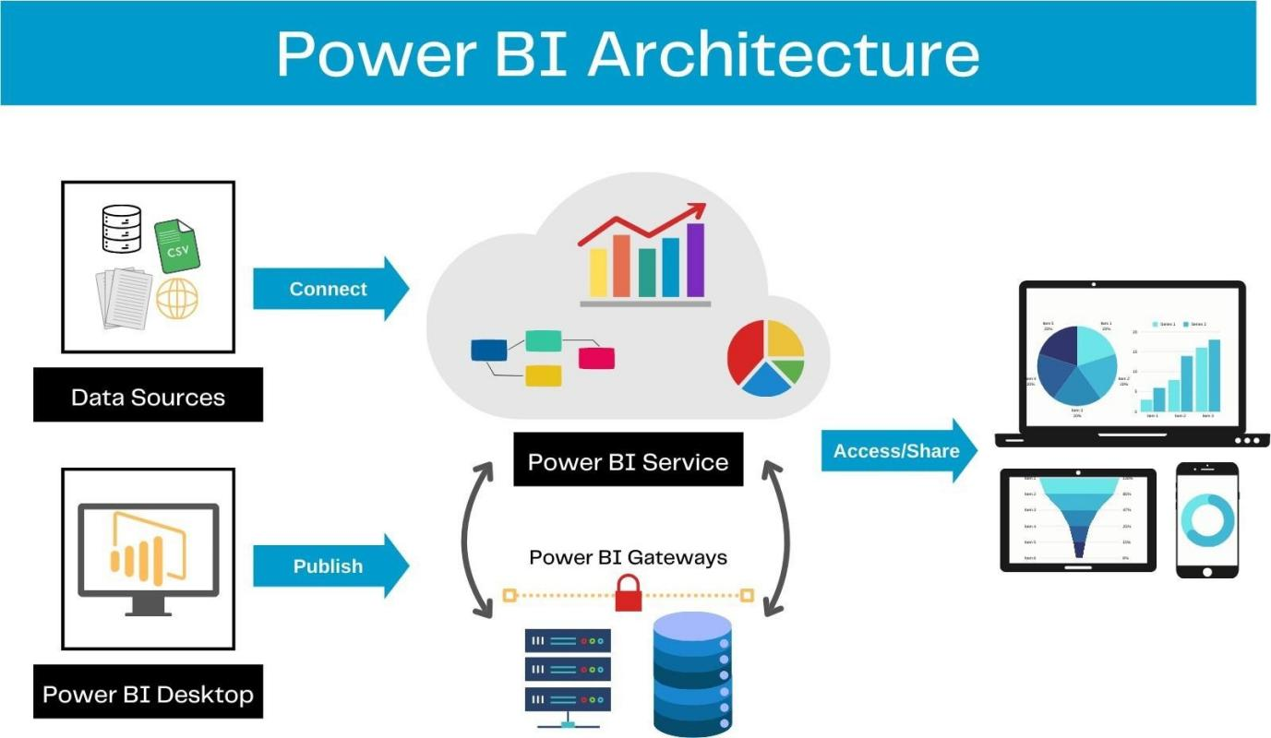

Power BI follows a three-layer architecture consisting of:

- Data Layer – Connects and extracts data from various sources.

- Processing Layer – Transforms and models data using Power Query and DAX.

- Presentation Layer – Displays data using reports and dashboards.

1. Data Layer – Connecting to Data Sources

Power BI supports multiple data sources, including:

- Databases: SQL Server, MySQL, PostgreSQL, Oracle

- Cloud Services: Azure, Google BigQuery, Snowflake

- Files: Excel, CSV, JSON, XML

- APIs & Web Data: REST APIs, SharePoint, Google Analytics

2. Processing Layer – Data Transformation & Modeling

- Power Query: Used for cleaning and transforming data.

- Data Modeling: Relationships between tables, star and snowflake schemas.

- DAX (Data Analysis Expressions): Used for creating calculated columns and measures.

3. Presentation Layer – Reports & Dashboards

- Reports: Pages containing visualizations, slicers, and filters.

- Dashboards: A collection of pinned visuals from different reports.

- Interactivity: Drill-through, cross-filtering, and tooltips.

Power BI Workflow
- Get Data → Connect to a source.

- Transform Data → Clean and shape the data.

- Model Data → Define relationships and calculations.

- Create Visuals → Build reports with charts, tables, and filters.

- Publish & Share → Upload to Power BI Service for collaboration.

Power BI Installation & Setup

➢ Installing Power BI Desktop

Power BI Desktop is a free application for building reports and dashboards. Follow these steps to install it:

Step 1: Download Power BI Desktop

- Visit the official Microsoft Power BI website and download Power BI Desktop.

- Alternatively, install it from the Microsoft Store.

Step 2: Install Power BI Desktop

- Open the downloaded .exe file and follow the on-screen installation instructions.

- Select the installation language and complete the setup.

Step 3: Launch Power BI Desktop

- Open Power BI Desktop after installation.

- Sign in using a Microsoft account (for full features).

- You'll see the Power BI Home Screen, where you can start creating reports.

➢ Power BI Service (Online) Setup

Power BI Service is the cloud-based platform for sharing reports and dashboards.

Step 1: Sign Up for Power BI Service

- Go to Power BI Service.

- Click Sign Up (use a business email; personal emails like Gmail/Yahoo may not work).

Step 2: Exploring Power BI Service

- Workspaces → Store and manage reports.

- Dashboards → Pin visuals for quick access.

- Datasets → Manage uploaded data sources.

- Reports → Create and edit interactive reports.

Installing Power BI Mobile App (Optional)
- Available on Android and iOS.

- Allows users to access reports and dashboards on the go.

Power BI Interface & Navigation

Power BI Desktop Interface Overview

When you open Power BI Desktop, you'll see the following key components:
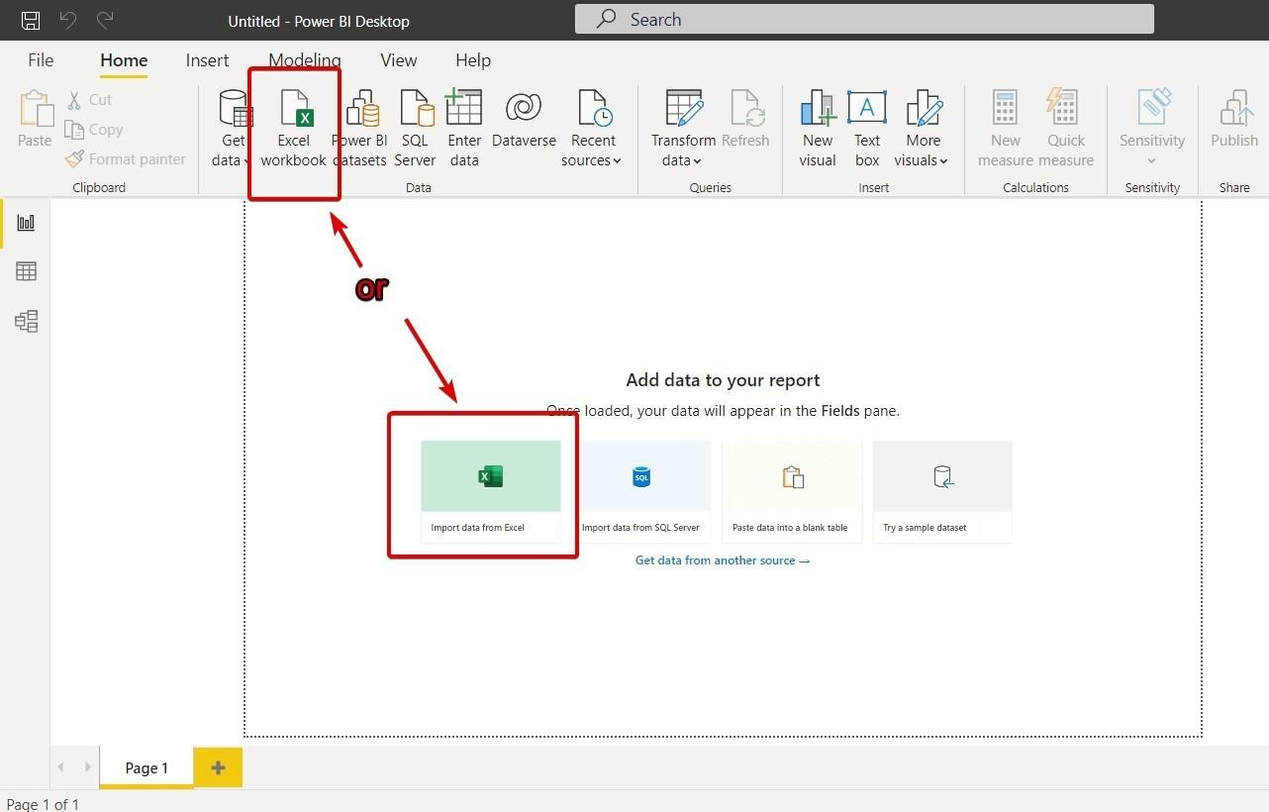

1. Home Screen

- Ribbon → Contains menus like Home, Insert, Modeling, View, and Help.

- Canvas → The main working area where reports are built.

- Fields Pane → Displays tables and fields from the dataset.

- Visualizations Pane → Contains various chart types and formatting options.

2. Main Views in Power BI Desktop

Power BI has three primary views accessible from the left sidebar:

View | Purpose
Report View | Used to create and design reports with charts, tables, and filters.
Data View | Displays raw data from tables for analysis.
Model View | Shows relationships between tables in a diagram format.

3. Power BI Service Interface

When using Power BI Service (Online), you’ll see:

- Workspaces → Storage areas for reports, datasets, and dashboards.

- Dashboards → Collection of pinned visuals for quick insights.

- Reports → Interactive visuals created in Power BI Desktop and published online.

- Datasets → The data sources uploaded to Power BI Service.

Key Navigation Tips
- Use File Menu to open, save, or publish reports.

- Right-click on fields in the Fields Pane to create measures or calculated columns.

- Use Filters Pane to apply page-level or report-level filters.
Views in Power BI
Power BI provides three key views: Report View, Data View, and Model View, each serving a specific purpose.

1.) Report View
This is the default view in Power BI Desktop where users build reports and dashboards. It allows adding and formatting visualizations, slicers, filters, and themes. Reports can be designed interactively, with cross-filtering between visuals and drill-through capabilities for deeper insights.
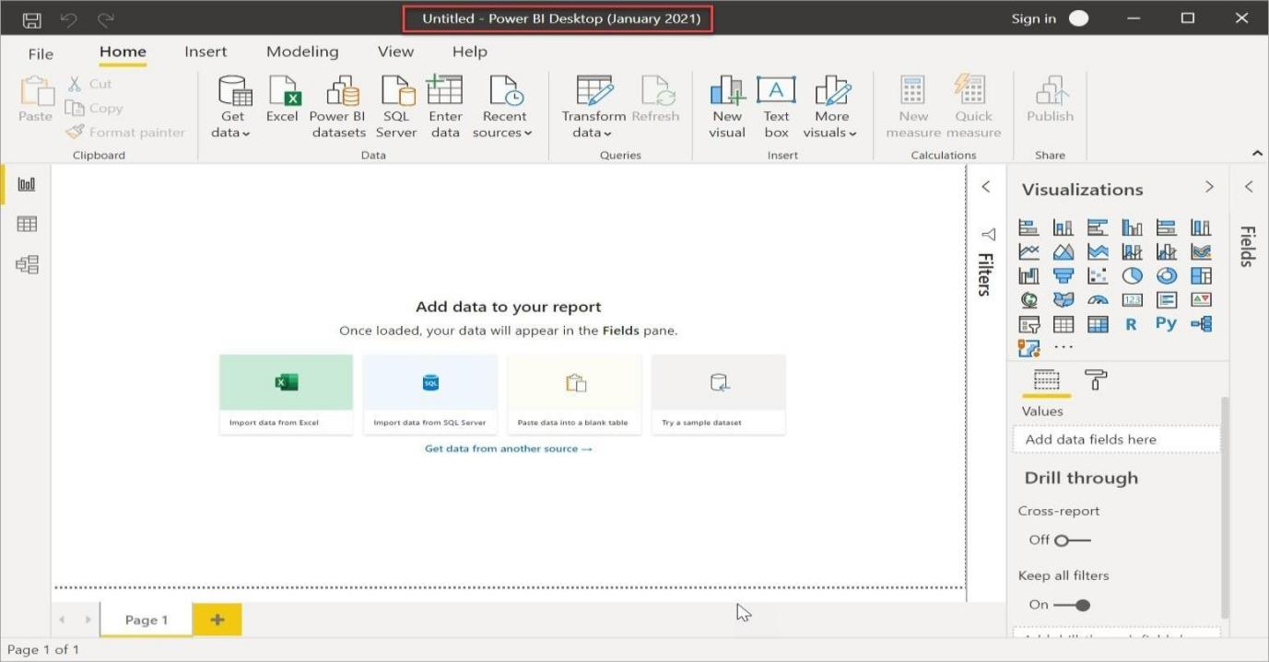

◆ Use Case: A sales team can create a report displaying monthly sales, customer demographics, and top-selling products, allowing dynamic filtering to analyze trends.

2.) Data View
This view displays imported data in tabular format, allowing users to inspect, verify, and perform basic transformations. Unlike Power Query, which is used for data transformation before loading, the Data View is mainly for checking the structure of tables after they have been loaded into Power
BI.
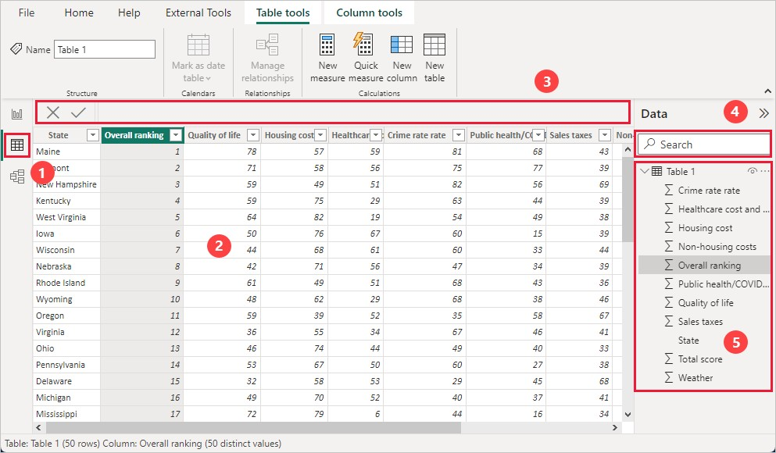

◆ Use Case: A finance analyst can verify the cleaned transactions dataset before applying complex calculations.

3.) Model View
Model View displays tables and relationships visually in a diagram format.

It allows defining one-to-one, one-to-many, and many-to-many relationships between tables.

Users can also create hierarchies and manage cardinality (data relationships) for efficient data modeling.

◆ 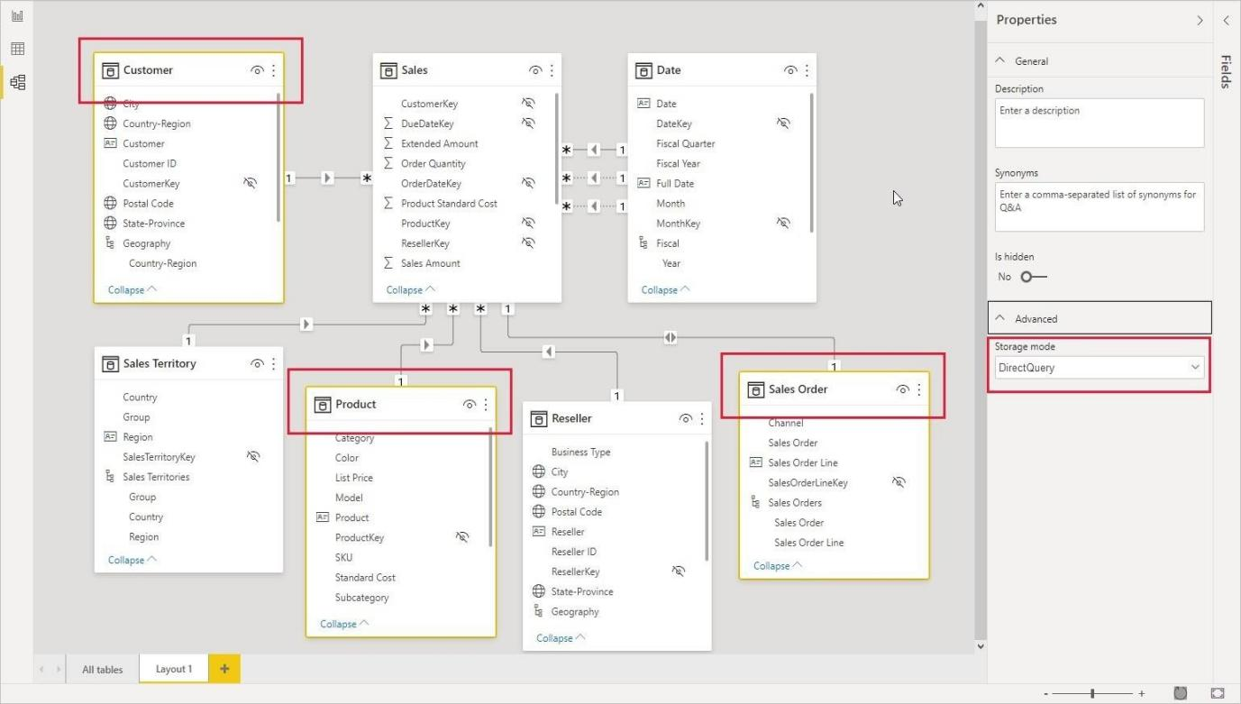
Use Case: In an e-commerce sales report, a user can create a relationship between the Orders table and Customers table to analyze purchases by customer segments.
◆

◆ Visualizations in Power BI
◆ Power BI provides a wide range of built-in and custom visualizations to represent data effectively.
◆

◆ Basic Visuals
◆
Visualizatio n | Description | Use Case
Bar Chart | Compares values across categories. | Monthly sales by product category.
Column  Chart | Displays trends over time. | Sales performance over multiple years.
Line Chart | Shows patterns and trends over time. | Website traffic analysis.
Pie Chart | Represents proportions in a dataset. | Market share of different brands.
Table | Displays raw data in rows and columns. | Employee salary details.
Matrix | A table with hierarchical grouping. | Region-wise sales performance.
◆

Advanced Visuals

Visualizatio n | Description | Use Case
Scatter Plot | Shows relationships between two numerical variables. | Correlation between  advertising budget and revenue.
TreeMap | Displays hierarchical data using nested rectangles. | Contribution of product categories to total sales.
Card | Displays a single KPI or metric. | Total revenue for the current month.
Gauge | Shows progress towards a goal. | Percentage of target sales achieved.
Map  Visuals | Represents geographic data. | Customer distribution across cities.

Custom Visuals

Power BI allows users to import custom visuals from Microsoft AppSource. Some examples include:

- Sankey Diagram – For visualizing data flow between categories.

- Bullet Chart – For comparing performance against a benchmark.

- Word Cloud – For text-based data analysis.

 Use Case: A marketing analyst can use a Word Cloud to identify the most frequently mentioned keywords in customer reviews.

Filters in Power BI
Filters allow users to refine data dynamically at different levels of a report.

Types of Filters

Filter Type | Description | Use Case
Visual-Level  Filter | Applies only to a specific visualization. | Filtering sales data for a single product category in a bar chart.

Page-Level Filter | Affects all visuals on a report page. | Filtering a dashboard to show sales data only for 2024.
Report-Level  Filter | Applies to all pages in a report. | Displaying only  "Retail"  sector data across all pages.
Drillthrough  Filter | Enables deep analysis by navigating to a detailed report. | Clicking on a city in a dashboard to view city- specific sales trends.
Slicer | An interactive visual element for filtering. | Allowing users to select a specific year for analysis.
◆ Use Case: A sales report can have a slicer for "Product Category", enabling users to filter sales data dynamically.

Slicers in Power BI
Slicers provide an intuitive way to filter data directly on a report page. They allow users to filter reports dynamically without modifying filters manually.
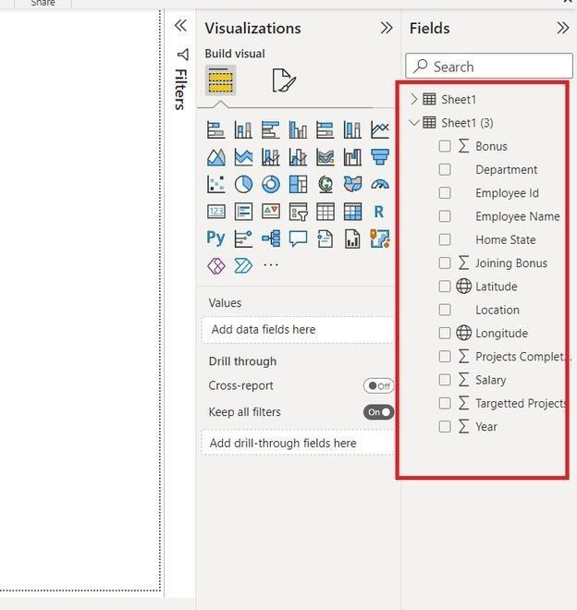

Types of Slicers

- Dropdown Slicer – Select a single value from a list.

- List Slicer – Select multiple values using checkboxes.

- Range Slicer – Adjust numerical values or dates using a slider.

- Hierarchical Slicer – Filter data using a multi-level structure.

 Use Case: In a sales dashboard, a Region Slicer allows users to select a specific region (North, South, East, West) and analyze sales performance dynamically.

Power Query Editor
Power Query Editor is used for data transformation and cleansing before loading data into Power BI. It offers a user- friendly interface to shape, filter, merge, and modify data.
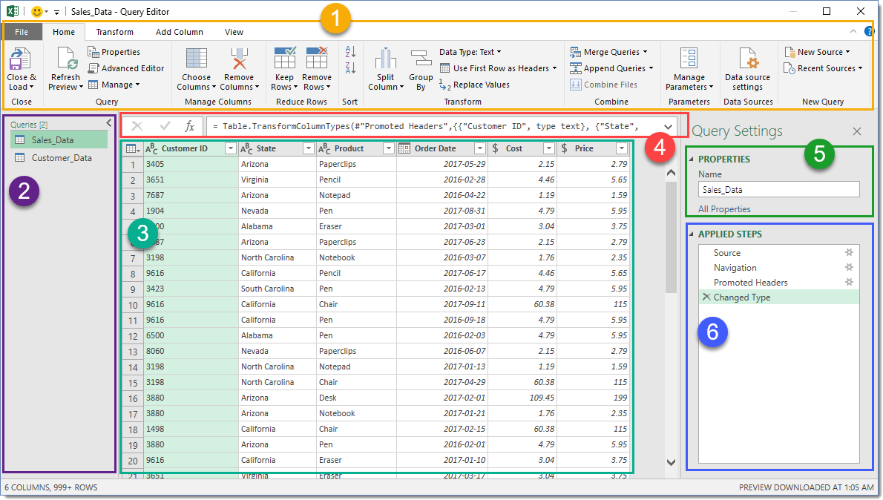

Key Features of Power Query

- Data Cleaning – Remove duplicates, replace missing values.

- Data Transformation – Merge, append, pivot, and unpivot data.

- Column Operations – Split, merge, rename, and create new columns.

- Applied Steps – Records every transformation step for easy tracking.

- M Language – A functional language used for advanced data transformations.

 Use Case: An HR analyst can use Power Query to clean an employee dataset, removing missing values and standardizing job titles before analysis.

Power Query Elements in Power BI – How to Open and Use
Power Query is a powerful tool in Power BI used for data extraction, transformation, and loading
(ETL). It allows users to connect to various data sources, clean and shape data, and load it into Power BI for analysis. Below is a detailed breakdown of each Power Query element, including how to open and use them.

1. Power Query Editor

Power Query Editor is the interface where users perform data transformation tasks. It consists of multiple sections, including the Home Tab, Transform Data, and Applied Steps Pane.

How to Open

- Open Power BI Desktop.

- Click "Transform Data" in the Home Tab.

How to Use

- Use the Close & Apply button to save changes and load data into Power BI.

- Perform data cleaning tasks like removing duplicates, merging columns, replacing values, and filtering rows.
◆ Use Case: An analyst removes duplicate customer records using Remove Duplicates before loading data.

2. Queries Pane

The Queries Pane (on the left side) lists all imported tables and data sources. Users can rename, duplicate, or reference queries.

How to Open

- Open Power Query Editor.

- The Queries Pane appears on the left, listing all queries.

How to Use

- Right-click a query to rename, duplicate, or reference it.

- Select a query to see its data and applied transformations.

◆ Use Case: A retail company imports Orders, Customers, and Products tables and references them in different transformations.

2. Data Preview Pane

The central area displays data in a tabular format. Users can view column names, data types, and applied steps.

How to Open

- Open Power Query Editor.

- The central section displays the data preview.

How to Use

- Scroll through the preview to check for incorrect or missing values.

- Verify that each column has the correct data type before transformations.

◆ Use Case: A user verifies that the "Date" column is formatted as a Date type before performing time-based analysis.

3. Applied Steps Pane

Located on the right, it records every transformation step, allowing users to edit, reorder, or delete actions. How to Open
- Open Power Query Editor.

- The Applied Steps Pane appears on the right side.

How to Use

- Click any step to modify, reorder, or remove it.

- Use "Undo" to revert unwanted changes.

◆ Use Case: A user removes blank rows, converts text values to uppercase, and merges two tables—each step is recorded for future modifications.

2. Data Transformation Tools

Power Query provides multiple tools to clean and transform data, including column operations, row operations, and data type conversion.

How to Open

- Open Power Query Editor and select a table.

- Transformation tools appear under the "Transform" tab.

How to Use

- Column Operations: Remove, rename, split, or merge columns.

- Row Operations: Remove duplicates, filter rows, or remove errors.

- Data Type Conversion: Convert numbers, dates, and text types.

◆ Use Case: Splitting a "Full Name" column into First Name and Last Name.

3. Data Filtering & Sorting

Users can filter rows based on conditions and sort data in ascending or descending order.

How to Open

- Open Power Query Editor.

- Click on the drop-down menu of any column.

How to Use

- Apply filters based on text, numbers, or date conditions.

- Use sorting options to arrange values in ascending or descending order.

◆ Use Case: Filtering a Sales dataset to show only transactions from 2023 onwards.

7. Merge Queries & Append Queries

Merge Queries

Joins two or more tables based on a common column (like SQL JOIN).

How to Open

- Open Power Query Editor.

- Click "Merge Queries" in the Home Tab.

How to Use

- Choose two tables and select a common column.

- Choose the Join Type (Inner, Left, Right, Full, etc.).

◆ Use Case: Combining a Customers table and an Orders table using a Customer ID field.

Append Queries
Stacks data from two or more tables with identical columns.

How to Open

Open Power Query Editor.

Click "Append Queries" under the Home Tab.

How to Use

Select two or more tables with the same structure.

Click OK to combine them into one dataset.

◆ Use Case: Combining Sales data from multiple regions (North, South, East, West) into one dataset.

8. Pivot & Unpivot Data

How to Open

- Open Power Query Editor.

- Click "Transform" → "Pivot Columns" or "Unpivot Columns".

How to Use

- Pivot: Converts row values into column headers.

- Unpivot: Converts column headers into row values.

◆ Use Case: Converting monthly sales data into a year-wise structured table for easier analysis.

2. Group By

Groups data based on a selected column and performs aggregations (sum, average, count, etc.).

How to Open

- Open Power Query Editor.

- Click "Transform" → "Group By".

How to Use

- Select a column to group data by.

- Choose an aggregation function (Sum, Count, etc.).

◆ Use Case: Grouping sales data by Region and calculating Total Sales per region.

3. Conditional Columns
Users can create new columns based on conditions (like Excel’s IF formula).

How to Open

- Open Power Query Editor.

- Click "Add Column" → "Conditional Column".

How to Use

- Set conditions based on existing column values.

- Define new column outputs based on conditions.

◆ Use Case: Creating a column that assigns "High" or "Low" labels based on profit margins.

4. Adding Custom Columns with M Language

How to Open

- Open Power Query Editor.

- Click "Add Column" → "Custom Column".

How to Use

- Write custom formulas using M Language for advanced calculations.

2. Parameters in Power Query

How to Open

- Open Power Query Editor.

- Click "Manage Parameters" in the Home Tab.

How to Use

- Create dynamic values that update across multiple queries.

◆ Use Case: Creating a parameter for "Start Date" and "End Date" to filter sales transactions dynamically.

3. Query Dependencies View

How to Open

- Open Power Query Editor.

- Click "View" → "Query Dependencies".

How to Use

- Analyze relationships between different queries in a visual format.

◆ Use Case: Understanding how Sales Data depends on Product and Customer tables before making transformations.

Data Modeling & Relationships
Power BI supports data modeling by creating relationships between multiple tables.

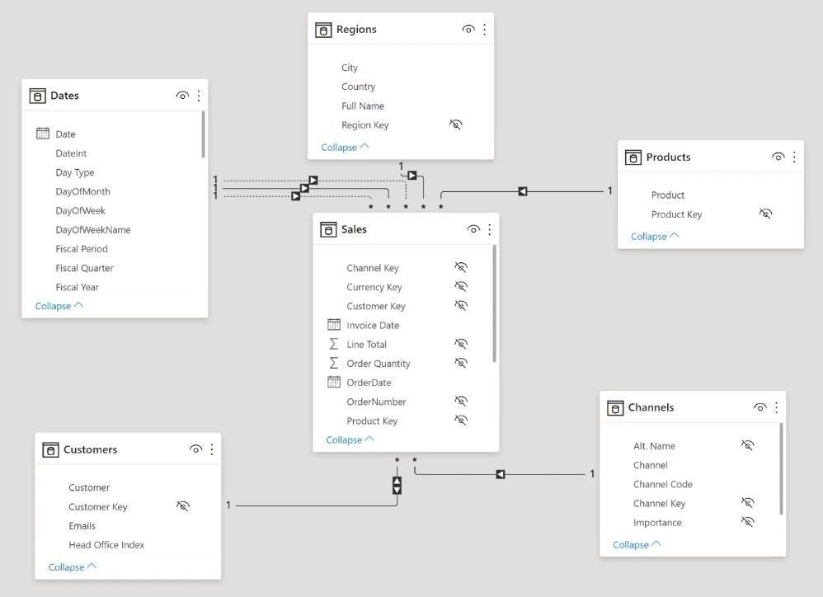
Data modeling is a crucial step in Power BI that allows users to establish relationships between different tables, ensuring seamless analysis and reporting. Below is a structured guide covering how to open, use, and optimize data models and relationships in Power BI.

1. What is Data Modeling
in Power BI?

Data modeling is the process of structuring data from multiple sources into a relational model. It involves:

• Creating relationships
between tables.

- Defining calculated columns and measures using DAX (Data Analysis Expressions).

- Optimizing model performance by reducing redundancy.

◆ Example Use Case: A company has Sales, Customers, and Products tables. Instead of merging them, relationships are created between tables using Customer ID and Product ID for efficient analysis.

2. How to Open the Data Model in Power BI?

To access the data model:

- Open Power BI Desktop.

- Click on the Model View icon ( ³) in the left navigation pane.

- The data model window displays all tables and relationships visually.

◆ Shortcut: Press Ctrl + M to quickly open the Model View.

3. Types of Relationships in Power BI

Power BI supports three types of relationships between tables:

1. One-to-Many (1:n) Relationship

□ Most commonly used relationship in Power BI.

□ One record in the first table relates to multiple records in the second table.

□ Example: A Customers table (one customer) linked to an Orders table (many orders).

2. Many-to-One (n:1) Relationship

□ Essentially the reverse of One-to-Many.

□ A common example is when filtering from the fact table to the dimension table.

3. Many-to-Many (n:n) Relationship

□ Used when multiple records in one table relate to multiple records in another table.

□ Requires a bridge table or composite model to avoid ambiguity.

□ Example: A Students table and a Courses table where students enroll in multiple courses.

4. One-to-One (1:1) Relationship

□ Each record in one table corresponds to exactly one record in another table.

□ Used when a large table is split for performance reasons.

□ Example: A Customer table split into Customer Basic Info and Customer Financial Info.

4. How to Create Relationships in Power BI?

Method 1: Using Model View (Drag-and-Drop)

- Open Model View.

- Drag a column from one table and drop it onto the matching column in another table.

- A relationship line appears automatically.

◆ Example: Drag Customer ID from Customers Table to Sales Table to create a One-to-Many relationship.

Method 2: Using Manage Relationships Dialog

- Go to Modeling → Manage Relationships.

- Click New → Select Tables and Columns to relate.

- Choose the relationship type (1:* , :, or 1:1).

- Click OK to create the relationship.

5. Cardinality in Power BI Relationships

Cardinality defines how rows from one table relate to rows in another table.

Cardinality  Type | Definition | Example
One-to-  Many  (1:*) | One row in Table A relates to multiple rows in Table B | One Customer has multiple Orders
Many-to-  Many (:) | Multiple rows in Table A relate to multiple rows in Table  B | A Student enrolls in multiple Courses, and a Course has multiple  Students
One-to-One  (1:1) | One row in Table A relates to one row in  Table B | A User has one Profile

◆ Best Practice: Prefer One-to-Many (1:*) relationships where possible for better performance.
6. Relationship Cross-filter Direction

Determines how filters propagate across related tables.

Power BI Service & Publishing
Power BI Service is a cloud-based platform that allows users to publish, share, and collaborate on reports and dashboards. Below are the key concepts and features of Power BI Service.

1. Power BI Service Overview

- Cloud-Based: Power BI Service (app.powerbi.com) is an online platform where users can publish, share, and collaborate on reports.
- Storage & Security: Data is stored in Microsoft’s cloud, ensuring security and access control.

- Subscription Plans: Power BI Service has different licensing options:

□ Power BI Free: Basic report publishing (limited sharing).

□ Power BI Pro: Enables collaboration, sharing, and data refresh scheduling.

□ Power BI Premium: Includes advanced AI, paginated reports, and large-scale datasets.

2. Publishing Reports from Power BI Desktop

• After creating a report in Power BI Desktop, you can publish it to Power BI Service:

□ Steps to Publish:

- Click on File > Publish > Power BI Service.

- Select a workspace (My Workspace or a shared workspace).

- Click Publish and wait for the process to complete.

3. Workspaces in Power BI Service

Workspaces are collaboration environments where teams can manage reports and datasets.

- My Workspace: Personal space for individual users (not shareable).

- Shared Workspaces: Collaborative environments where multiple users can access reports and datasets.

- App Workspaces: Used for publishing reports as an application for end-users.

◆ Best Practice: Use separate workspaces for development, testing, and production to ensure a structured report management process.

4. Creating & Managing Dashboards

- A dashboard is a collection of visuals from multiple reports, providing a summarized view of data.

- Users can pin report visuals to a dashboard for easy access.

- Dashboards can include data from multiple datasets and reports.

◆ Use Case: A sales manager creates a dashboard with key metrics like total revenue, topselling products, and regional sales performance.

5. Sharing & Collaboration

Power BI Service enables users to share reports and collaborate with team members.

- Sharing Reports:

□ Click on Share in a report or dashboard.

□ Enter the email address of the recipient.

□ Set permissions (view/edit access).

- Collaboration Features:

□ Comments: Users can add comments to reports and dashboards.

□ Co-Authoring: Multiple users can work on the same report in a shared workspace.

◆ Best Practice: Use Power BI Pro or Premium for seamless sharing and collaboration.

6. Data Refresh & Scheduled Refresh

- Power BI Service allows automatic data refresh to keep reports up-to-date.

- Manual Refresh: Click on the refresh button in Power BI Service.

- Scheduled Refresh: Set a specific time for data updates (e.g., daily at 9 AM).

- Gateway Refresh (for on-premises data sources):

□ Requires Power BI Gateway to refresh data from local databases (SQL Server, Excel, etc.).

◆ Best Practice: Schedule refresh during off-peak hours to avoid performance issues.

9. Power BI Security & Row-Level Security (RLS)

- Row-Level Security (RLS) restricts data access based on user roles.

- Admins can define roles and rules to control who sees what data.

◆ Example of RLS Rule in DAX:

[Region] = USERPRINCIPALNAME()

(This ensures users see only the data for their assigned region.)

◆ Use Case: A company restricts sales data so that regional managers see only their assigned region’s data.
What is Visualization in Power BI?
Power BI Visualization is the process of representing data graphically to identify trends, outliers, and patterns using visual elements such as charts, graphs, maps, etc.

📊 2. Commonly Used Visuals
Visual Type | Purpose
Bar/Column Chart | Compare values across categories
Line Chart | Show trends over time
Pie/Donut Chart | Show proportions of a whole
Table | Display data in rows and columns
Matrix | Pivot-table-like summary
Card | Show single KPI (Key Metric)
Gauge | Display performance against a target
Treemap | Show hierarchical data
Map/Shape Map | Visualize geographic data
Slicer | Filter visuals interactively
Combo Chart | Combine line and bar charts

🎨 3. Customizing Visuals
- Data Labels: Show actual values on the chart.
- Title: Add meaningful titles for clarity.
- Legends: Useful for identifying categories in multi-series charts.
- Axis Formatting: Adjust scales, colors, labels.
- Themes: Predefined color schemes for consistent design.
- Tooltips: Show details on hover.
- Interactions: Use “Edit interactions” to control how visuals affect each other.

🔧 4. Filters and Slicers
- Visual-Level Filter: Applies to only one visual.
- Page-Level Filter: Applies to all visuals on a single page.
- Report-Level Filter: Applies across all pages in the report.
- Slicer: Interactive filter visual that users can control.

🧮 5. DAX for Visualization
Common DAX Measures used in Visuals:
dax
CopyEdit
Total Sales = SUM(Sales[SalesAmount]) Average Sales = AVERAGE(Sales[SalesAmount])
Sales Target Met = IF([Total Sales] > 100000, "Met", "Not Met")
Running Total = CALCULATE(SUM(Sales[SalesAmount]), FILTER(ALL(Sales),
Sales[Date] <= MAX(Sales[Date])))

🏗️ 6. Drill Features
- Drill Down: View detailed levels of hierarchical data (e.g., Year → Month → Day).
- Drill Through: Navigate to another page with filtered data.
- Expand All: Show all levels in hierarchy at once.

📌 7. Bookmarking & Selection Pane
- Bookmarks: Save specific views for storytelling.
- Selection Pane: Manage visibility of visuals.
- Buttons: Create navigation between pages or views.

🧠 8. Best Practices
Use proper | chart | types for | the | data.
Avoid |  | cluttered |  | visuals.
Use KPIs | and | cards for | key | metrics.
Limit colors | to | make | visuals | readable.
Use tooltips  Test interactivity between visuals. | to | provide | more | insights.

🔁 9. Useful Visual Tips
Need | Use This
Compare multiple values | Clustered Bar/Column Chart
Show part-to-whole relationship | Pie/Donut/Treemap
Time Series Analysis | Line/Area Chart
KPIs at a glance | Card/Gauge
Filter report easily | Slicer
Hierarchical data | Matrix, Treemap, Drill-down Charts

🧩 10. Custom Visuals
Power BI offers custom visuals through AppSource like:
• Bullet Chart • KPI Indicator • Chiclet Slicer • Radar Chart • Word Cloud
Install via: Visualizations Pane → … (Get more visuals)

PROJECT WORK
TITLE: AIR QUALITY ANALYSIS WITH POWER BI
PROJECT OVERVIEW
Introduction:
Air quality monitoring is essential for ensuring the health and well-being of the population, as poor air quality can have severe impacts on human health and the environment. In urban areas, tracking air quality is particularly crucial to identify pollution hotspots, understand seasonal trends, and develop strategies for pollution reduction. Through the analysis of air quality data, organizations can make informed decisions to improve public health and air quality policies.
Project Description:
The Air Quality Analysis with Power BI project was designed to analyze and visualize air quality data to gain meaningful insights into pollution levels and their effects on health and the environment. Using data downloaded from Kaggle, the project focused on building an interactive dashboard that provides an overview of air quality metrics, trends, and correlations. Power BI was utilized for data cleaning, visualization, and creating interactive reports that are easy to understand for stakeholders.
Data Description:
The dataset for this project is sourced from Kaggle and includes hourly air quality measurements from multiple locations over several years. It contains data on various pollutants such as PM2.5, PM10, CO2, NO2, and ozone levels, along with metadata such as location, timestamp, and weather conditions. The dataset offers a rich view of air quality, enabling the analysis of both short-term and long-term trends in urban environments.
Key Objectives
- Develop an interactive dashboard to visualize air quality metrics such as PM2.5, PM10, and CO2 levels across different locations and time periods.
- Analyze the impact of weather conditions and other external factors on air quality.
- Provide actionable insights to help policymakers and environmental organizations make data-driven decisions regarding air quality management.
- Identify pollution hotspots and periods of poor air quality for targeted interventions.
Learning Objectives:
- Data Cleaning and Transformation:
Students will learn how to clean and preprocess large environmental datasets using Power BI’s data transformation features.
- Data Visualization Techniques:
Students will learn how to create interactive and insightful visualizations such as line charts, bar charts, heat maps, and scatter plots.
- Correlation and Trend Analysis:
Students will analyze the relationships between different pollutants and external factors such as weather, time of day, and location.
- Power BI Features:
Students will gain hands-on experience with Power BI’s key features, including data transformation (Power Query), DAX calculations, and dashboard design.
Methodology
- Data Extraction and Processing:
  - Download the air quality dataset from Kaggle. o Clean and preprocess the data by handling missing values, removing outliers, and ensuring proper data formats using Power BI’s data transformation tools.
- Exploratory Data Analysis (EDA):
  - Perform an initial analysis to identify key variables such as PM2.5, PM10, and CO2 levels.
  - Investigate trends over time, variations by location, and the impact of weather conditions on air quality.
- Data Transformation and Feature Engineering:
  - Create new columns and metrics that enhance analysis, such as air quality index (AQI) or weather-related features (e.g., temperature, wind speed).
  - Use Power BI’s DAX functions to create calculated columns and measures for deeper insights.
- Dashboard Development:
  - Design an interactive Power BI dashboard that allows users to filter data by date, location, and pollutant type.
  - Use visualizations such as time series, bar charts, and maps to display air quality metrics.
  - Implement drill-down functionality for detailed analysis on specific time periods or regions.
- Report Sharing and Publishing:
  - Publish the Power BI report to the Power BI service, enabling stakeholders to access and interact with the dashboard.
  - Set up scheduled data refreshes to ensure the dashboard reflects the latest data.
Expected Outcomes
- A fully functional and interactive Power BI dashboard that provides detailed insights into air quality trends and pollutant levels across different regions.
- Identified trends in air quality based on time of year, location, and weather conditions.
- Insights into high pollution periods and locations, aiding in the development of strategies for mitigating poor air quality.
- Actionable recommendations for government and environmental organizations to improve air quality and reduce health risks related to pollution.
Results and Findings
Summarized Dashboard Performance and Key Findings:
- Dashboard Functionality:
  - The dashboard enables users to view air quality data across different time periods and locations, providing an intuitive way to explore trends and patterns. o Heat maps showed the geographical distribution of pollutants, highlighting areas with the highest levels of air pollution.
- Key Findings:
  - Air Quality Trends: Analysis revealed seasonal fluctuations in air quality, with higher pollution levels in colder months, likely due to increased heating and traffic.
  - Impact of Weather Conditions: Wind speed and temperature were found to have a significant impact on pollution levels, with higher winds correlating with lower pollution concentrations.
  - Pollution Hotspots: Certain urban areas showed consistently poor air quality, particularly in regions with high traffic or industrial activity.
- Insights and Recommendations:
  - Policy Recommendations: Based on identified pollution hotspots, local governments could implement stricter regulations on industrial emissions and traffic control in high-risk areas.
  - Health Impact Awareness: The dashboard could be used by health organizations to provide timely warnings about air quality and potential health risks, particularly for vulnerable populations such as children and the elderly. o Public Awareness Campaigns: Promote awareness about the importance of air quality monitoring and encourage citizens to take action when pollution levels are high.
Conclusion and Recommendations Conclusion:
The Air Quality Analysis with Power BI project successfully demonstrated the power of data visualization in understanding and communicating air quality trends. By utilizing Power BI’s interactive features, the project provided an intuitive and accessible way for stakeholders to explore air quality data, uncover insights, and make data-driven decisions.
Recommendations:
- Regular Monitoring and Reporting:
  - Continue to monitor air quality data and refresh the dashboard regularly to reflect the latest trends. o Publish periodic reports for public awareness and environmental monitoring agencies.
- Targeted Interventions:
  - Focus on areas with the worst air quality and implement targeted measures to reduce pollution, such as promoting clean energy or enhancing green spaces.
- Collaborations with Policy Makers:
  - Work with environmental policy makers to integrate insights from the dashboard into air quality management programs and regulations.
- Further Research:
  - Incorporate additional data sources such as socio-economic factors or population density to assess the broader impact of air pollution.
- Public Awareness Campaigns:
  - Use the dashboard to inform citizens about the risks of poor air quality, providing recommendations on actions they can take to reduce exposure.

ACTIVITY LOG FOR FIRST WEEK
Day | Brief description of daily activity | Learning outcome | Person in-charge signature
Day 1 | What is AI-driven data analytics?  Overview of key terms: ML, AI, Big Data, Data Science. Why AI is important. Real-world applications: Healthcare, Retail, etc. | - Understood the role of AI in analytics  - Differentiated between AI,  ML, and Data Science  - Identified AI applications in various industries
Day 2 | Data collection, cleaning, analysis, model building, evaluation, deployment, and tools | - Learned full data pipeline flow  - Identified tools used in each stage (e.g., Pandas, Sklearn)  - Gained awareness of model evaluation and deployment
Day 3 | Structured vs unstructured data, CSV/JSON/XML formats, storage systems, DataFrames | - Differentiated data types and formats  - Practiced loading and viewing data  - Understood use of  DataFrames (Pandas)
Day 4 | Basic Python syntax: Variables, loops, conditions | - Wrote simple Python programs  - Applied loops and conditional logic  - Understood syntax and indentation rules
Day 5 | Basic Python syntax: Variables, loops, conditions | - Reinforced Python  concepts  - Applied logic in real scenarios  - Increased coding confidence and debugging skills

WEEKLY REPORT

WEEK - 1 (From Dt 29 May 2025 to Dt 4 June 2025)
Objective of the Activity Done:
The main objective of this activity was to introduce participants to the foundational concepts and practical workflow of AI-driven data analytics. The focus was to build awareness and hands-on knowledge of Artificial Intelligence, Machine Learning, Big Data, and the importance of Python programming in the data analytics lifecycle—from data collection to deployment. The activity aimed to prepare students for real-world data challenges by combining theoretical insights with coding practice.

Detailed Report:
The training activity focused on introducing participants to the fundamentals and practical applications of AI-driven data analytics. The session began with an explanation of key concepts such as Artificial Intelligence (AI), Machine Learning (ML), Big Data, and Data Science. Participants explored the significance of AI in today’s data-centric world, including its impact on industries like healthcare, agriculture, finance, and retail. Emphasis was placed on understanding how AI and data analytics work together to generate insights and make intelligent decisions.
As the training progressed, participants were guided through the complete data analytics pipeline. This included the process of data collection, cleaning, analysis, model building, evaluation, and deployment. They learned about the tools and technologies used at each stage of the data workflow, with a focus on Python-based libraries such as Pandas, NumPy, and Scikit-learn. The training emphasized how clean and well-structured data is critical for building accurate AI models.
Further, participants gained an understanding of different types of data, including structured and unstructured formats. They learned to handle and process commonly used file formats such as CSV, JSON, and XML. They were also introduced to the concept of data storage systems and how data can be represented and manipulated using DataFrames for effective analysis.

ACTIVITY LOG FOR SECOND WEEK

Day | Brief description of daily  activity | Learning outcome | Person in-charge signature
Day - 1 | Python libraries: NumPy, Pandas | - Understood NumPy arrays and operations  - Learned data  manipulation with Pandas
Day - 2 | Python libraries: ,Pandas | - Practiced loading, filtering, and cleaning data using Pandas
Day - 3 | Python libraries: Pandas | - Applied advanced Pandas functions (merge, pivot, groupby) for data  transformation
Day – 4 | Encoding,Scalling | - Learned how to preprocess data using encoding and scaling  techniques
Day – 5 | Introduction of Matplotlib | - Created basic data visualizations using plots, bars, and histograms

WEEKLY REPORT

WEEK - 2 (From Dt 5 June 2025 to Dt 11 June 2025)
Objective of the Activity Done:
The objective of this activity was to provide participants with practical knowledge and handson experience in using essential Python libraries and data preprocessing techniques required for data analysis and machine learning. The sessions aimed to build a strong foundation in data handling, transformation, and visualization using libraries such as NumPy, Pandas, and Matplotlib, as well as introduce preprocessing techniques like encoding and scaling.

Detailed Report:
The training program focused on developing participants’ proficiency in Python libraries widely used in the field of data analytics and machine learning. The sessions began with an introduction to NumPy, where students learned about working with arrays, performing mathematical operations, and handling multidimensional data efficiently. This was followed by a detailed exploration of the Pandas library, which is crucial for data manipulation and analysis. Participants practiced loading datasets, handling missing values, filtering, sorting, and performing group-wise operations using DataFrames and Series.In subsequent sessions, more complex aspects of Pandas were covered, including merging datasets, pivoting, and applying functions to clean and transform data. The training then moved on to data preprocessing techniques such as encoding categorical variables using label and one-hot encoding, and scaling numerical features using standardization and normalization. These techniques are vital for preparing data before feeding it into machine learning models.The final session introduced Matplotlib, a powerful visualization library in Python. Participants learned to create different types of plots such as line plots, bar graphs, and histograms. These visual tools enable data analysts to derive insights and communicate findings effectively. Overall, the training equipped learners with the ability to handle data programmatically and laid a strong groundwork for further exploration into data science and AI.

ACTIVITY LOG FOR THIRD WEEK

Day | Brief description of daily  activity | Learning outcome | Person in-charge signature
Day 1 | Create visualizations using Matplotlib | - Learned to create plots (line, bar, histogram, scatter)  - Understood customization and labeling
Day 2 | What is ML? Overview of supervised learning | - Understood the concept of Machine Learning  - Differentiated supervised vs unsupervised learning
Day 3 | What is ML? Overview of classifcation | - Gained knowledge of classification algorithms like KNN, Decision Tree  - Learned evaluation metrics
Day 4 | Introduction to unsupervised learning, clustering | - Understood clustering concepts like K-Means  - Learned how to group  unlabeled data
Day 5 | Dimensionality | - Learned the importance of dimensionality reduction  - Understood PCA  (Principal Component  Analysis) basics

WEEKLY REPORT

WEEK - 3 (From Dt 12 June 2025 to Dt 18 June 2025)
Objective of the Activity Done:

The objective of this activity was to introduce participants to key concepts in Machine Learning and Data Visualization using Python. Through hands-on practice and theoretical learning, the aim was to help learners understand the distinctions between supervised and unsupervised learning, learn core classification and clustering algorithms, visualize data using Matplotlib, and grasp the importance of dimensionality reduction techniques in simplifying data without significant loss of information. This foundational training was designed to prepare participants for real-world data science tasks and future AI projects.
Detailed Report:
This five-day training activity focused on building a practical understanding of Machine Learning and data visualization techniques. The sessions began with an introduction to Matplotlib, a Python library used for visualizing data. Participants learned how to create various types of plots including line charts, bar graphs, scatter plots, and histograms. This helped them understand how to explore and communicate data insights effectively through visuals.
Following that, the program introduced the concept of Machine Learning, starting with supervised learning, where participants learned how models are trained using labeled data. The idea of training and testing a model to predict outcomes based on input features was thoroughly discussed. The next session zoomed into classification algorithms, such as K-Nearest Neighbors (KNN) and Decision Trees. Learners explored how these models are used to categorize data into predefined classes and how to evaluate them using metrics like accuracy and confusion matrix.
The course then moved to unsupervised learning, focusing on clustering techniques such as K-Means, where participants understood how to group similar data points when no labels are available. This session demonstrated how AI can find hidden patterns and groupings within data. The final part of the training covered dimensionality reduction, a technique used to reduce the number of input features while preserving essential data characteristics. Participants were introduced to Principal Component Analysis (PCA) and its role in simplifying complex datasets, improving performance, and visualizing high-dimensional data.
By the end of the activity, participants gained hands-on experience with machine learning models, understood key algorithms, and were able to create meaningful visualizations. This program laid a strong foundation for applying machine learning in real-world applications.

ACTIVITY LOG FOR FOURTH WEEK

Day | Brief description of daily  activity | Learning outcome | Person in-charge signature
Day 1 | SQL introduction and installation and data types | - Understood SQL basics, setup environment  - Learned different SQL data types
Day 2 | commands | - Learned to create, insert, and retrieve data using basic SQL commands
Day 3 | constrains | - Understood and applied constraints like PRIMARY  KEY, FOREIGN KEY, NOT  NULL, UNIQUE, CHECK
Day 4 | sql joins | - Learned different types of joins and how to combine  data from multiple tables
Day 5 | group by ,order by,where,like etc.. | - Applied clauses to filter, group, and sort data for  targeted queries

WEEKLY REPORT

WEEK - 4 (From Dt 19 June 2025 to Dt 25 June 2025)
Objective of the Activity Done:
The objective of this activity was to introduce participants to the fundamentals of Structured Query Language (SQL) and its role in database management. The training focused on understanding SQL syntax, executing essential commands, applying constraints, performing joins, and using clauses such as GROUP BY, ORDER BY, WHERE, and LIKE to extract meaningful insights from data. This foundational knowledge equips participants with the skills necessary to interact with databases and perform structured data analysis efficiently
Detailed Report:

The five-day SQL training provided participants with a comprehensive understanding of database management through structured query language. The program began with an introduction to SQL, including installation steps, understanding of different data types, and how SQL is used to store, retrieve, and manage data in relational databases. Participants were given an overview of database structures and how tables are created using appropriate data types.
In the next phase, participants learned essential SQL commands such as CREATE, INSERT, SELECT, UPDATE, and DELETE. These commands are fundamental for performing operations on databases, and hands-on practice allowed learners to apply them effectively on sample datasets. Following this, the concept of constraints like PRIMARY KEY, FOREIGN KEY, UNIQUE, NOT NULL, and CHECK was introduced. These constraints ensure data accuracy, integrity, and consistency in relational database systems.
Participants then explored SQL joins, including INNER JOIN, LEFT JOIN, RIGHT JOIN, and FULL JOIN, which are crucial for combining data from multiple tables based on related columns. Real-world scenarios were used to demonstrate the importance of joins in building meaningful data relationships. The final session focused on query clauses such as GROUP BY, ORDER BY, WHERE, and LIKE. These are essential for filtering, sorting, and grouping data based on specific conditions to generate targeted results.
By the end of the training, participants gained practical knowledge of SQL programming and were able to write efficient queries to manipulate and retrieve data from relational databases. This training laid a strong foundation for roles involving data analytics, database administration, and backend development.

ACTIVITY LOG FOR FIFTH WEEK

Day | Brief description of daily activity | Learning outcome | Person signature | in-charge
Day - 1, | IIntro, Components, Architecture,  Installation,nterface, Connecting  Data Sources | - Understood Power BI  architecture  - Installed and explored the interface  - Connected and imported data sources
Day - 2 | Relationships (1:1, 1:m, M:m), star vs snowflake schema, managing relationships, role-playing dimensions | - Learned to create and manage data model relationships  - Understood schema types and their role in modeling
Day - 3 | DAX Calculated Column vs  Measure, SUM, COUNT,  AVERAGE, DISTINCT,IF, SWITCH,  Core of Dynamic DAX | - Practiced core DAX  functions  - Understood difference between calculated  columns and measures
Day - 4 | Bar, Line, Pie, Funnel  Charts,Maps, Cards, KPIs, Tables vs Matrix | - Created different types of visualizations  - Understood visual components and when to use them
Day - 5 | Tooltips and Drillthrough,  Grouping and Binning | - Implemented interactivity using tooltips and drillthrough  - Applied grouping and binning for detailed analysis

WEEKLY REPORT

WEEK - 5 (From Dt 26 June 2025 to Dt 1 Aug 2025 )
Objective of the Activity Done:
The objective of this activity was to provide participants with a comprehensive understanding of data visualization and business intelligence using tools like Power BI. The training aimed to build skills in data connectivity, modeling relationships, writing DAX formulas, and designing effective dashboards and reports. By the end of the program, participants were expected to be capable of building interactive and dynamic reports to derive actionable insights from various data sources.
Detailed Report:
The training program introduced participants to the fundamentals and advanced features of Power BI, a leading business intelligence and data visualization tool. The sessions began with an overview of the tool's interface, its architecture, and the steps required for installation and setup. Participants also learned how to connect different data sources such as Excel, SQL Server, and online services, gaining hands-on experience in data import and transformation.
Following the introduction, the focus shifted to data modeling and relationships, covering key concepts like 1:1, 1:many, and many-to-many relationships. Participants explored different schema designs, particularly star and snowflake schemas, and understood how to manage role-playing dimensions for better data structure and reporting accuracy.
Next, the sessions delved into DAX (Data Analysis Expressions), a powerful formula language used in Power BI. Participants learned the differences between calculated columns and measures, and practiced using core DAX functions such as SUM, COUNT, AVERAGE, DISTINCT, IF, and SWITCH. The concept of dynamic DAX was emphasized to demonstrate how to build more flexible and user-responsive reports.
In the visualization phase, participants designed interactive dashboards using visual components such as bar, line, pie, and funnel charts, along with maps, KPIs, cards, and matrices. They learned to choose the appropriate visual based on the type of data and reporting requirements. Finally, advanced interactivity features like tooltips, drillthrough pages, grouping, and binning were covered, enabling users to add depth and detail to their reports for better end-user analysis.
Overall, the training equipped participants with the necessary skills to handle real-world data visualization projects. They gained the ability to design professional, interactive dashboards that could help in data-driven decision-making in any business context.

ACTIVITY LOG FOR SIXTH WEEK

Day | Brief description of daily activity | Learning outcome | Person in-charge  signature
Day - 1 | Static vs Dynamic RLS, RLS in  Models, live connection, export to Excel | - Understood the use of static and dynamic RLS - Applied security filters in models  - Practiced live connections and Excel export
Day - 2 | Power BI Services | - Learned to navigate Power BI Service  - Understood workspaces, dashboards, and sharing reports
Day - 3 | How to create power bi service account | - Created and configured Power BI accounts - Understood licensing, permissions, and  workspace setup
Day - 4 | Project | - Applied knowledge to a live BI project  - Implemented RLS, visuals, and data  connections in realworld context
Day - 5 | Project | - Published project to Power BI Service - Demonstrated secure sharing and data access based on user roles

WEEKLY REPORT

WEEK - 6 (From Dt 2 Aug 2025 to Dt 7 Aug 2025)
Objective of the Activity Done:
The objective of this activity was to introduce learners to Power BI Service features, RoleLevel Security (RLS) implementation, and project development using cloud-based dashboards. The goal was to enable participants to apply access-level control to data, publish and share reports via the Power BI Service, and manage real-time data collaboration. By the end of the training, participants were expected to be proficient in deploying complete BI solutions with secure access.
Detailed Report:
This five-day training and project activity centered around advanced features of Power BI, focusing on data security and report deployment through Power BI Service. The sessions began with an in-depth discussion on Role-Level Security (RLS), comparing static vs dynamic RLS techniques. Participants learned how to restrict data access at the row level, ensuring users only see data relevant to their roles. They also explored how to configure RLS within the data model and work with live data connections, enhancing the performance and security of dashboards. Additionally, they practiced exporting reports and datasets to Excel, enabling extended analysis.The following session covered Power BI Service, Microsoft’s cloud-based platform for sharing, collaborating, and managing Power BI reports. Learners explored features like workspaces, dashboards, datasets, scheduled refresh, and dataflows. They learned how to publish Power BI reports from desktop to service and share them with stakeholders securely.Participants were then guided through the process of creating a Power BI Service account, understanding licensing models (Pro vs Free), and setting up a workspace for their team. They gained hands-on experience in managing users, assigning roles, and configuring permissions for controlled access to reports.The final two days were dedicated to a practical project, where participants applied all the concepts learned throughout the course. They built a complete Power BI solution, implemented row-level security, and published the report to Power BI Service. They also configured sharing options and demonstrated how users with different roles would view customized data securely through the service platform.This activity not only strengthened technical skills in Power BI but also prepared participants to work on real-world, secure, and scalable BI projects suitable for enterprise environments.

